REPORT
Report on radiation-and-environmental monitoring in the area of the Belarusian Nuclear Power Plant

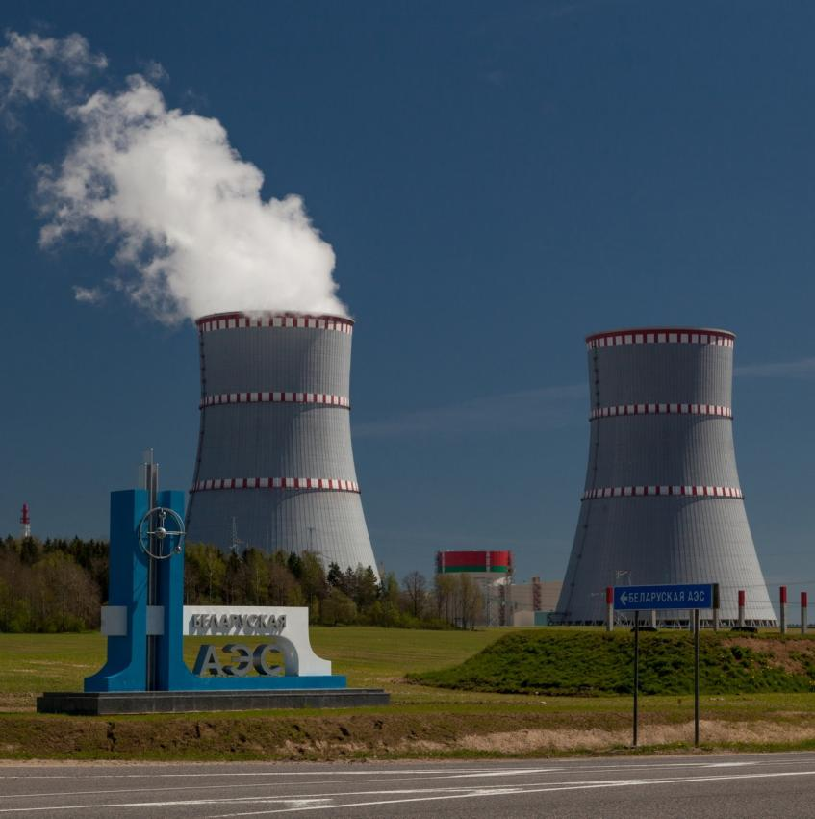

2022

CONTENTS
Introduction |  |  | 3
Chapter 1 |  | General description of the Belarusian NPP | 3
Chapter 2 |  | Core activity of the Belarusian NPP | 5
Chapter 3 |  | Integrated management and radiation safety assurance policies of the Belarusian NPP and their realization | 8
Chapter 4 |  | Environmental and quality management system | 10
Chapter 5 |  | Basic documents regulating the environment protection activities of the Belarusian NPP and radiation-and-environmental monitoring activities | 13
Chapter 6 |  | System for assurance of technical competence and laboratory inspection independence in accordance with GOST ISO/IEC17025-2019 | 15
Chapter 7 |  | Industrial ecological observations | 16
Chapter 8 |  | Environmental impact | 19
Chapter 9 |  | Radiation-and-environmental monitoring at observation points of the National Environmental Monitoring System of the Republic of Belarus, located outside of the observation zone of the Belarusian NPP | 57
Chapter 10 |  | Awareness raising in the field of radiation-and-environmental monitoring | 65

Introduction

The Radiation-and-Environmental Monitoring Report for 2022 in the area of the State Enterprise “Belarusian Nuclear Power Plant” (hereinafter - the Belarusian NPP) was developed within the frames of implementation of the Program of the post-project analysis of the Belarusian NPP (approved by the Ministry of Natural Resources and Environmental Protection of the Republic of Belarus on December 23, 2014) in order to fulfill the Convention on Environmental Impact Assessment in a Transboundary Context (Espoo) obligations by the Republic of Belarus (Article 7). The monitoring has been carried out by specialized Belarusian and foreign organizations.

CHAPTER 1
General description of the Belarusian NPP

The Belarusian NPP is located in the Ostrovets district of the Grodno region of the Republic of Belarus, 18 km northeast of the city of Ostrovets (Fig. 1.1).
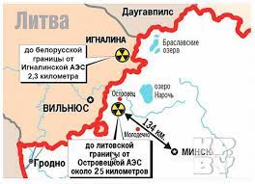
Figure 1.1 - Map of the Belarusian NPP location

The neighboring states are Lithuania (the distance to the border – 20,4 km), Latvia (the distance to the border – 106 km), Poland (the distance to the border – 194 km), the Russian Federation (the distance to the border – 200 km), Ukraine (the distance to the border – 315 km).
The distance from the Belarusian NPP site to the capital of the Republic of Belarus, Minsk, is 134 km.
The Belarusian NPP, consisting of two power units with a total electrical capacity of up to 2400 MW with VVER-1200 reactors, is being built according to the Russian project “NPP-2006” of 3+ generation near the city of Ostrovets (Grodno region). This project meets the most up-to-date so-called “post-Fukushima” standards of reliability and safety, which is achieved by the introduction of new “passive safety systems” that are able to function without the operators intervention even in case of complete blackout of the plant.

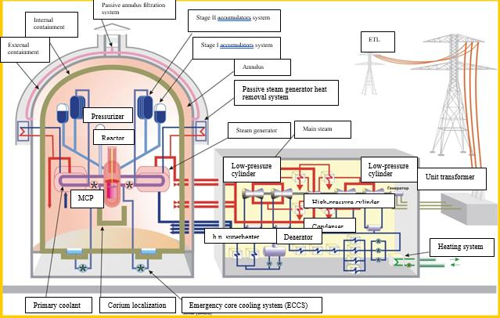
Figure 1.2 - Actual layout of the NPP power unit with VVER-1200

Key technical and economic parameters:
power unit nominal capacity – 1200 MW(e);
number of power units – 2;
power unit life time – 60 years;
efficiency (net) – 33.7%;
NPP electricity demand – maximum 7.15% of the rated capacity.
The safety of the Belarusian NPP project is ensured via the defense-in-depth principle - the use of a system of barriers on the way of the ionizing radiation and radioactive substances spread to the environment.
The barrier system includes:
– a fuel matrix preventing the release of fission products under the fuel element can;
– a fuel element cladding preventing fission products from getting into the coolant of the main circulation circuit;
- the main circulation circuit, preventing the fission products release under the containment;
- a system of containments preventing the fission products release into the environment.
The safety of the Belarusian NPP project has been repeatedly confirmed by experts from the International Atomic Energy Agency (hereinafter – IAEA) and the World Association of Nuclear Operators. The experience of Belarus in the nuclear power plant project implementation was duly appreciated by the international nuclear community.
The site of the Belarusian NPP occupies an area of about 1 km².
In accordance with the project the territory of the Belarusian NPP site coincides with the boundaries of the sanitary-protection zone (hereinafter referred to as the SPZ), and the observation zone (hereinafter referred to as the OZ) is a circle of 12,9 km radius.
Belarusian NPP uses an indirect service water supply with cooling towers and spray cooling ponds system.
The water intake site for service water supply system is located 7 km to the north of the Belarusian NPP site on the Viliya River near the settlement of Malye Sviryanki. The site of the II elevation structure is located 0,25 km to the north of the settlement of Matskely.
The water intakes for the household water supply system are located 6 km to the south-east of the Belarusian NPP near the settlement of Gaigoli, and the settlement of Popishki. The water intake system includes 4 areas of water intake and a site of the household water treatment plant.

CHAPTER 2
Core activity of the Belarusian NPP

On June 10, 2021 the State Acceptance Commission signed a Provisional Acceptance Certificate of the power unit No. 1 start-up complex of the Belarusian NPP into commercial operation.
From the date of the first synchronization of the turbine generator of the power unit No. 1 of the Belarusian NPP with the energy system of the Republic of Belarus (November 03, 2020) until the end of 2022 10.8 billion kWh of electricity were generated.
First preventive maintenance of the Belarusian NPP power unit No. 1 had been conducted since April 25, 2022. All maintenance activities were done in November 09, 2022, the Belarusian NPP power unit No. 1 was connected to the grid and brought to the nominal capacity.
As of the end of 2022 the construction and technological readiness of the Belarusian NPP power unit No. 2 is about 97 %. The work of B stage “Physical start-up” has been continued.
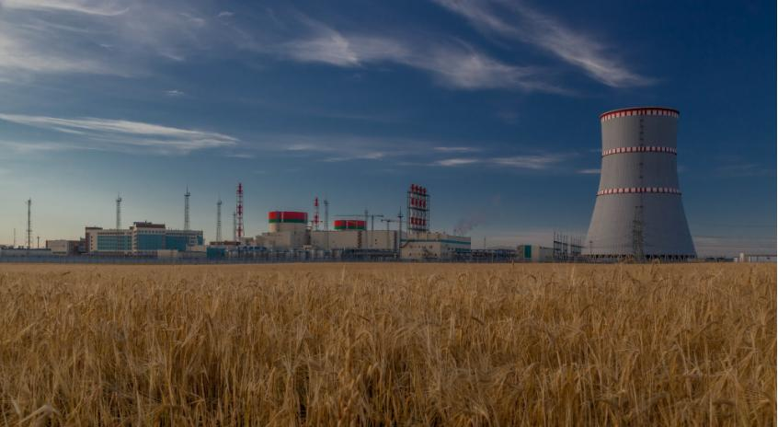
In 2023 the commissioning of the Belarusian NPP power unit No. 2 will continue.
Figure 2.1 – Belarusian Nuclear Power Plant

In order to improve nuclear and radiation safety systems during the construction, commissioning and operation of the Belarusian NPP, to gain external expert support of international experts the Belarusian NPP actively cooperates with international organizations such as the IAEA, the World Association of Organizations, Operated Nuclear Power Plants (hereinafter – WANO), the European Nuclear Safety Regulators Group (hereinafter – ENSREG), etc.
The project BYE2008 “Enhancing the Operational Safety of the Nuclear Power Plant during Commissioning and Operation” is under the implementation. During 2022 within the framework of this project, the following activities were carried out: an expert mission (workshop) on the repair of technological equipment and components, to reduce the time and improve the quality of repair work (via videoconferencing); scientific visits of Belarusian specialists to reference NPPs of the Russian Federation to gain experience in the field of maintenance and repair of process equipment and components, planning of the procurement of goods, works, services for operating NPPs.
From 24, to 25 January, 2022 the visit of the Team leader of pre-startup peer review of the Belarusian NPP power unit No.2 of WANO Moscow center (hereinafter-WANO-MC) was organized.
From March 23, 2022 to March 25, 2022, a preliminary visit of the WANO-MC corporate peer review was organized and conducted, during which organizational issues of the corporate peer review were discussed, interviews were conducted with employees of the Belarusian NPP. At the end of the visit, the protocol to prepare for the corporate peer review was signed.
From 16 to 20 May, 2022, a working meeting of WANO-MC was organized on the topic: “WANO Performance Indicators”. The main topics of discussion were the implementation of “the NPP Performance Indicators” subprogram within the framework of WANO, the results of “the NPP Performance Indicators” subprogram in 2021, a review of WANO performance indicators, long-term performance targets, the WANO index, the collection and quality of source data on production indicators, entrance of source data into the electronic database DES (Data Entry System), reporting on performance indicators from the database, use of performance indicators in WANO events, analytical application WAT (WANO Assessment Tool), review of performance indicators systems used in WANO companies, implementation of ongoing WANO projects regarding performance indicators.
From 22 to 28 August 2022, a WANO-MC support mission “Operating Experience. Event investigation. Identification of root and immediate causes” was held. During the mission, the participants of the event discussed the following issues:
• identifying the root causes of events;
• development of corrective measures;
• use of operating experience in daily work;
• methodology for determining the immediate and root causes and contributing factors of various types of events at nuclear power plants;
• nonconformity management;
• self-assessment;
• insignificant events.
At the end of the WANO-MC support mission, the Final Report was provided.
From 19 to 29 September 2022, a corporate peer review of WANO-MC was held. During the peer review, the effectiveness of the Belarusian NPP activities was assessed in the following areas: corporate leadership; corporate governance; corporate supervision and monitoring; corporate independent supervision; corporate support; corporate human resource management and leadership development; corporate communication. To assess the production activities of the enterprise, documentation was reviewed, observations and interviews were conducted with the managers of the enterprise and NPP personnel. In many areas, production activities are carried out at a high level, and recommendations for improvement were made in some areas.

CHAPTER 3
Integrated management and radiation safety assurance policies of the Belarusian NPP and their realization

In 2020, the Belarusian NPP has introduced the Integrated Management System Policy (hereinafter – IMS). The environmental management system is a part of the IMS.
In 2021 the IMS of the Policy of the State Enterprise «Belarussian NPP» (hereinafter – IMS Policy) was reissued at the Belarusian NPP. The management of the Belarusian NPP has assumed obligations to implement the IMS Policy, including the environmental protection through the prevention, mitigation and minimization of possible adverse environmental impacts associated with the activities of the Belarusian NPP.
The objectives of the IMS Policy in terms of environmental management are:
– production of electricity and heat while ensuring safety, including environmental safety, as the highest priority;
– rational use of natural resources.
The objectives can be achieved by implementing the applicable requirements and other commitments made in the field of environmental protection.
Awareness of all new employees of the IMS Policy shall be ensured as part of basic training on environmental protection. Implementation of the integrated management system policy in 2022 during the construction of the Belarusian NPP was ensured by:
– compliance with the requirements of the legislation of the Republic of Belarus in the field of environmental protection and rational use of natural resources;
– protection of the environment by preventing, mitigating and minimizing possible adverse environmental impacts associated with the operation of the facility.
Observations in accordance with the Program of Integrated Environmental Monitoring of the Belarusian NPP were performed and the parameters of the environment status of the Belarusian NPP were evaluated.
In order to perform industrial environmental control and assess facilities having a harmful effect on the environment, the Belarusian NPP developed “Activities for environmental protection of the Republican Unitary Enterprise “Belarusian Nuclear Power Plant” and fully implemented:
– in terms of industrial waste management, based on the results of an early inventory of industrial wastes, the Standards for the generation of industrial wastes of the republican unitary enterprise "Belarusian Nuclear Power Plant" were established and approved, and changes were made to the permit for the storage and disposal of industrial wastes;
– new permit for special water use was obtained: changes were made to the water quality standards for surface water bodies, incl. maximum permissible concentrations of chemical and other substances in the water of surface water bodies;
– sources of continuous pollutant emissions into the air on the Belarusian NPP site were accounted and changes in the project documentation, regarding adjustments of permissible pollutant emissions into the atmospheric air, were made, on the basis of which a new permit for the emission of pollutants into the air was obtained. An inventory of pollutant emissions to air at the site of the Belarusian NPP has been started with development of standards for permissible levels of pollutant emissions;
– research work «International experience in providing research with seismological monitoring networks observational data in the areas of NPP location with technology development and access procedure to data from the Belarusian network» was performed.
As an operator, and in accordance with the regulation of the Republic of Belarus in the field of atomic energy use, the Belarusian NPP declares that ensuring radiation safety is also one of the priorities in the area of atomic energy use.
The radiation safety policy at the Belarusian NPP was implemented on April 22, 2019.
The Belarusian NPP uses the atomic energy in accordance with:
– provisions of the international treaties, agreements and conventions related to radiation safety ratified by the Republic of Belarus;
– provisions of the national legislation of the Republic of Belarus related to radiation safety;
- provisions of the local regulations of the Belarusian NPP related to radiation safety;
– recommendations of the IAEA related to radiation safety.
The goal of the radiation safety policy is to protect people now and in future from the harmful effects of ionizing radiation.
The main task of the radiation safety policy implementation is to create the conditions for the most effective implementation of the policy goal.
Implementing the radiation safety policy the Belarusian NPP follows the next three main principles:
– prohibiting of any activities with use of ionizing radiation sources if the benefit does not exceed the risk of possible harm caused by the exposure, additional to the natural background;
– ensuring that the dose limits are not exceeded;
– maintaining of exposure at the lowest possible and achievable level taking into account economic and social factors and the number of exposed persons using ionizing radiation sources.
The Belarusian NPP declares to consider and support any initiatives of employees aimed at maintaining and improving radiation safety.

CHAPTER 4
Environmental and quality management system
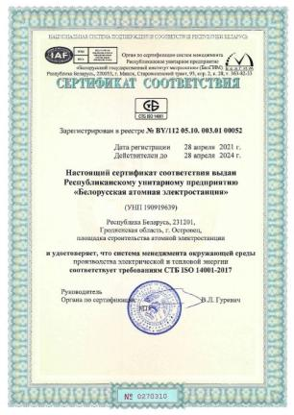
1. In 2022, the independent authority for management systems certification the Republican unitary enterprise “Belarusian State Institute of Metrology” conducted the periodic evaluation of the environmental management system (hereinafter referred to as the EMS) to meet the requirements of the STB ISO 14001- 2017.
As a result, a positive assessment of the functioning of the environmental management system was obtained.
Leading the environmental activities, the Belarusian NPP is guided by the following basic principles:
– ensuring compliance of the operational activities with legislation and international requirements in the field of environmental protection;
– assessment of the envisaged activity environmental impact by identifying and assessing the environmental aspects of the activity;
– identification of high environmental risks of the results of NPP activities and development of measures aimed to prevent or reduce the harmful impact of the enterprise to the environment and high environmental risks management;
– minimization of the negative impact of the NPP to the environment;
– transparency and accessibility of environmental information.
In 2022 in order to ensure high environmental performance of the Belarusian NPP, the following activities were implemented:
- Standard of enterprise STO 1.1.1.006.0009-2022 «Basic rules of environmental protection at a nuclear power plant» was developed. This standard sets the basic requirements for environmental protection for the State Enterprise «Belarusian NPP» during the operation of the nuclear power plant;
- updated goals and risks register of the IMS process passport “Environmental safety management” PP ISU 04-OOOS for 2023;
- recommendations reflected in the report on the analysis of the functioning of the EMS for 2022 were implemented, work to identify new environmental aspects of the enterprise’s structural units was carried out;
- analysis of the functioning of the process PP ISU 04-OOOS-2021 «Environmental Safety Management» for 2021 was carried out. Targets for environmental safety were achieved. Based on the analysis results, the process is recognized to be successful. Planned activities to improve the process were implemented.
Structural units of the Belarusian NPP conducted an analysis of theirs’ activities to update environmental aspects and related to them environmental impacts. The environmental aspects were assessed and the “Register of Environmental Aspects of the State Enterprise “Belarusian NPP” for 2023 was created.
2. The existing and functioning IMS of the Belarusian NPP represents a complex of interrelated documented and manageable processes aimed to achieving target indicators that are implemented in compliance with established requirements.
The IMS of the Belarusian NPP includes such aspects of safety as nuclear safety, radiation safety, industrial security, fire safety, engineering safety, nuclear security, environmental safety, labor protection by separation of the relevant processes, as well as such elements as quality assurance, human and institutional factors, socio-economic aspects. The highest priority of the Belarusian NPP is to ensure safety.
By now within the frames of the IMS of the Belarusian NPP, the enterprise has implemented, operates, maintains up to date, and certifies in the National System of Conformity Assessment of the Republic of Belarus the following:
- a quality management system for the production of electricity and heat, performance of the customer's and developer's functions, delivery of engineering services during construction of facilities of 1-4 complexity classes in accordance with the requirements of STB ISO 9001-2015 “Quality management systems. Requirements” (certificate of conformity No. BY/112 05.01. 003.01.00510 dated December 02, 2022, valid until December 01, 2025);
- a health and safety management system for professional activities in the field of electricity and heat production in accordance with the requirements of STB ISO 45001-2020 “Health and safety management systems for professional activities. Requirements and implementation guidance” (certificate of conformity No. BY/112 05.04. 003.01.00051 dated 28.04.2021, valid until 28.04.2024);
– environmental management system for the production of electricity and heat in accordance with the requirements of STB ISO 14001-2017 “Environmental control (management) systems. Requirements and guidelines for use” (certificate of conformity No. BY/112 05.10. 003.01.00052 of April 28, 2021, valid until April 28, 2024).
The current IMS of Belarusian NPP includes:
- the IMS policy establishing the obligations of the top management to maintain and improve the IMS, goals in the field of IMS were adopted;
- the organizational structure and organizational charts were identified;
- the liability of the personnel (fixed in the Regulations of the enterprise units, job/work descriptions, organizational and administrative and other documents of the enterprise) was highlighted;
- the IMS Coordinating Council, the main tasks of which are to coordinate the operation of the enterprise within the IMS, maintain and constantly improve the IMS, follow-up the decisions taken at the meetings of the Coordinating Council was created and functioning;
- Decree No. 209 dated March 29 2022 appointed the authorized IMS representatives to ensure the compliance of the enterprise units with the IMS;
- IMS documents covering different fields of the enterprise’s activity (policies, guidelines, enterprise standards, regulations, process certificates, quality assurance for safety programs (general quality assurance program POKAS (O) to operate the power units of the Belarusian NPP POKAS (E), program POK (YaM (YaT) for handling nuclear materials (nuclear fuel)), POK (RAOe) for handling operational nuclear waste, POK (III) for handling sources of ionizing radiation) etc.) were developed;
- the development of programs of quality assurance for the General Contractor during the implementation of the Belarusian NPP POKAS (O1) project, designing the following quality assurance for safety programs: POKAS (P) for designing, POKAS (C) for construction and installation, POKAS (VE) for commissioning of the power units of the Belarusian NPP;
- revision of existing and development of new documents is carried out;
- IMS processes were identified;
- process owners and their liabilities identification were identified;
- the IMS process risks analysis and assessment are carried out, risk registers and processes risk management programs were developed and periodically amended;
- internal audits of the IMS, including control of compliance with the requirements of quality assurance programs, with a preparation of relevant documents (programs, plans, reports, corrective action plans) are carried out;
- external audits of supplier management systems, including control of compliance with the requirements of quality assurance programs, including preparation of relevant documents (programs, plans, reports, corrective action plans) are carried out;
- at a regular interval monitoring of the existing IMS processes and the activities of various departments is carried out;
- analysis is carried out by management;
- measures to improve the IMS are determined on an ongoing basis, etc.

CHAPTER 5
Basic documents regulating the environmental protection activities of the Belarusian NPP and radiation-and-environmental monitoring activities

1. “Convention on the Environmental Impact Assessment in a Transboundary Context” (Concluded in Espoo on February 25, 1991).
2. Law of the Republic of Belarus dated July 30, 2008 No. 426- Z “On the use of nuclear power”.
3. Law of the Republic of Belarus dated November 26, 1992 No. 1982-XII “On Environmental Protection”.
4. Law of the Republic of Belarus dated June 18, 2019 No. 198- Z “On Radiation Safety”.
5. Law of the Republic of Belarus dated December 16, 2008 No. 2-Z “On Atmospheric Air protection”.
6. Law of the Republic of Belarus dated July 20, 2007 No. 271-Z “On waste management”.
7. Code of the Republic of Belarus dated July 17, 2008 No. 406-Z “Subsoil Code of the Republic of Belarus”
8. Code of the Republic of Belarus dated April 30, 2014 No. 149- Z “Water Code of the Republic of Belarus”.
9. Code of the Republic of Belarus dated July 23, 2008 No. 425- Z “Land Code of the Republic of Belarus”.
10. Decree of the Council of Ministers of the Republic of Belarus dated July 14, 2003 No. 949 “On the National Environmental Monitoring System in the Republic of Belarus”.
11. Decree of the Council of Ministers of the Republic of Belarus dated April 28, 2004 No. 482 “About helding of certain types of environmental monitoring and using its data”.
12. Decree of the Council of Ministers of the Republic of Belarus dated May 17, 2004 No. 576 “About helding of radiation monitoring and using its data”
13. Decree of the Ministry of Natural Resources and Environmental Protection of the Republic of Belarus dated October 11, 2013 No. 52 “About helding of the industrial observations in the field of environmental protection, rational use of natural resources”.
14. STB ISO 9001-2015 “Quality management systems - Requirements”. International standard.
15. STB ISO 14001-2017 “Environmental Management Systems. Requirements and guidelines for use”.
16. GOST ISO/IEC 17025-2019. General requirements for the competence of testing and calibration laboratories.
17. Standards and rules for the radiation and nuclear safety ensuring “General requirements for ensuring the safety of nuclear power stations”, approved by the Decree of Ministry of emergency situations of the Republic of Belarus dated April 13, 2020 No. 15.
18. Standards and rules for the radiation and nuclear safety ensuring “Safety of nuclear plants in sanitary protection zone and surveillance zone. Requirements to radiation monitoring.” approved by the Decree of Ministry for emergency situations of the Republic of Belarus dated June 30, 2016 No. 29.
Other legislative and regulatory acts of the Republic of Belarus in the field of environmental protection.

CHAPTER 6
System for assurance of technical competence and laboratory inspection independence in accordance with GOST ISO/IEC17025-2019

1. At the plant supporting systems department of the Belarusian NPP (hereinafter referred to as PSSD), the production laboratory (hereinafter referred to as PL PSSD), which meets the criteria of the National Accreditation System of the Republic of Belarus and was established and accredited in compliance with the requirements of GOST ISO/IEC 17025-2019 “General requirements for testing and calibration laboratories” (certificate of Accreditation No. BY/112 2.4928 dated May 19, 2017).
The PL PSSD is accredited to analyze the drinking water quality for the following parameters: sampling (GOST 31862-2012), flavor (GOST 3351-74 п. (p.) 2), taste (GOST 3351-74 п. (p.) 3), color (GOST 31868-2012 (method B), turbidity (GOST 3351-74 п. (p.) 5), pH index (STB ISO 10523-2009), total hardness (GOST 31954-2012 (method A), ferrum (GOST 4011-72 п. (p.) 2), dry residue (GOST 18164-72 п. (p.) 3.1), permanganate index (STB ISO 8467-2009), total microbial count (MUK RB 11-10-1-2002 п. (p.) 8.1),thermotolerant coliform bacteria (MUK RB 11-10-1 -2002 п. (p.) 8.2), common coliform bacteria (MUK RB 11-10-1-2002 п. (p.) 8.2), sulfite-reducing clostridia spores (MUK RB 11-10-1-2002 п. (p.) 8.4). In December 2022, the activities was carried out to include into the scope of accreditation an analysis of the quality of drinking water in terms of indicators: synthetic surfactants (FR.1.31.2014.17189 (PND F 14.1:2:4.158-2000 (М01-06-2013)), oil products (PND F 14.1:2:4.128-98).
Also PL PSSD expanded the scope of its accredited activities to analyze the quality of surface and waste water as follows: sampling (GOST 31861-2012, STB 17.13.05-29-2014 / ISO 5667-10:1992), mass concentration of hydroxyethyledene-bisphosphonic acid of zinc disodium salt (MVI.MN 6332-2021), suspended solids (MVI.MN 4362-2012), water salt content (MVI.MN 4218-2012), total phosphorus (GOST 18309-2014 method D), total ferrum (STB 17.13.05-45-2016), pH index (STB ISO 10523-2009), chemical oxygen demand ( FR.1.31.2012.12706 (PND F 14.1:2:4.190-2003)), phosphate ion (GOST 18309-2014 method B) , ammonium ion (STB 17.13.05-09-2009 / ISO 7150-1:1984), nitrite ion (STB 17.13.05-38-2015), nitrate ion (STB 17.13.05-43-2015), chloride ion (STB 17.13.05-39-2015), sulfate ion (STB 17.13.05-42-2015), synthetic surfactants (FR.1.31.2014.17189 (PND F 14.1:2:4.158-2000 (М01-06-2013)), oil products (PND F 14.1 :2:4.128-98), temperature (MVI.MN 5350-2015). In December 2022 the activities by including into the scope of accredited activities for waste and surface water by the following indicator: mass concentration of hydroxyethylidene diphosphonic acid zinc disodium salt (АMI.МN 0015-2021).
The accreditation certificate was eхtended till May 19, 2027.
2. The design documentation of the Belarusian NPP envisage conduction of radiation monitoring as part of the radiation monitoring system in the SPZ and OZ of the Belarusian NPP with the help of the automated radiation monitoring system (hereinafter - ARMS) and the radiation monitoring laboratory (hereinafter - RML) of the radiation safety division ( accredited in the National Accreditation System of the Republic of Belarus in compliance with the requirements of GOST ISO/IEC 17025-2019 “General requirements for testing and calibration laboratories”, certificates of Accreditation No. BY/112 2.5262 dated January 22, 2021 and No. BY/112 1.1824 dated September 10, 2021).
ARMS is intended to conduct continuous radiation monitoring in the SPZ and OZ of the Belarusian NPP. The ARMS software and hardware includes 10 radiation control stations, 9 of which are located in the territory of the OZ and 1 – at the reference point outside the territory of the OZ (settlement of Svir), an automated weather station (settlement of Vornyany), 2 mobile radiometric laboratories, the main central control station (CCS ARMS in the Belarusian NPP site) and the backup central control station (CCS ARMS in Ostrovets).
RML is intended for periodic laboratory monitoring of the radionuclides activity concentrations in the environment (air, atmospheric fallout, precipitation, soil, groundwater, surface water, bottom sediments, aquatic and ground vegetation) in the SPZ and OZ of the Belarusian NPP, as well as in local agricultural products and food products (vegetables, fruits, milk, meat, fish, etc.).

CHAPTER 7
Industrial ecological observations

On the basis of Article 94 of the Law of the Republic of Belarus “On Environmental Protection” and in accordance with the Decree of the Ministry of Natural Resources and Environmental Protection of the Republic of Belarus dated October 11, 2013 No. 52 for the organization of industrial observations in the field of environmental protection, local regulatory documents and monitoring schedules have been developed:
- Standard of enterprise STO 1.1.1.006.0009-2022 «Basic rules of environmental protection at a nuclear power plant»;
- Guidelines for the observations in the field of environmental protection, rational use of natural resources at the Belarusian NPP;
- Guidelines for the production waste management at the Belarusian NPP;
- Procedure for radiation control of the Belarusian NPP;
- Program for radiation monitoring of the environment in the sanitary-protection zone and the observation zone of the Belarusian NPP;
- Guidelines on control of radioactive airborne and liquid discharges from the Belarusian NPP;
- Observation schedules for local monitoring;
- Observation schedules for the pollutant emissions into the air from stationary sources;
- Map of the sources of pollutant emission into the air for local monitoring;
- Map of observation wells as part of local groundwater monitoring;
- Map of harmful sources affecting the environment, including the points of testing and sampling.
The main tasks of industrial environmental observations at the Belarusian NPP are as follows:
- control over the implementation and compliance with the requirements of the environmental legislation of the Republic of Belarus;
- rational use of natural resources;
- control over the state of environment in the area, where it falls under the impact of economic activities connected with the construction of the Belarusian NPP;
- recording of the types and quantity of pollutants released into the environment as a result of economic and other activities;
- provision of up-to-date and reliable information about the environment state and pollution to be submitted to the state environmental control authorities, including the emergencies caused by economic and other activities of the Belarusian NPP;
– participation in the development and implementation of the state (republican, industrial, local and other) programs and activities on the rational use of natural resources and environment protection aimed at preventing and eliminating environmental pollution;
– control over the operation of the environmental protection equipment and constructions;
– organization and development of the system of education, upbringing in the field of environmental protection and fostering of the ecological culture, as well as training and retraining of specialists in the field of environmental protection.
Acts of industrial environmental control or Instruction acts (in case there are comments) are made up based on the results of industrial environmental observations.
The facilities of industrial environmental control include:
– construction site of the Belarusian NPP, including utility networks (service water supply, power supply, etc.);
– industrial facilities, which are in free use by the general contractor JSC “ASE”;
– industrial facilities, which are in use by the Belarusian NPP;
– housing facilities, which are in free use by the general contractor JSC ASE;
– housing facilities, which are in use by the Belarusian NPP;
– water supply sources (underground water supply in the Losha river basin; surface water intake from the Viliya river) and water discharge (surface-water body of the Viliya river; service water body of the Losha river basin - evaporation pond in the territory of military unit 7434);
– production and consumption waste sources: manufactories, work sites, technological processes and processing phases;
– emissions of pollutants into the atmospheric air by stationary (auxiliary boiler, block-modular gas boiler house) and mobile pollution sources;
– wastewater discharges into water bodies, including sewerage systems and water discharge networks, wastewater treatment systems;
– surface water in the area of wastewater discharge sources;
– groundwater near identified or potential sources of pollution;
– lands (including soils) near identified or potential sources of pollution;
– plants.
At the Belarusian NPP is organized and carried out analytical (laboratory) control in the field of environmental protection with the help of accredited testing laboratories.
In accordance with the Decree of the Ministry of Natural Resources and Environmental Protection of the Republic of Belarus dated January 11, 2017 No. 5, the Belarusian NPP has been included in the list of legal entities performing local monitoring since July 22, 2020. Local monitoring objects are:
– pollutant emissions into the atmospheric air from technological and other equipment, technological processes, machines, mechanisms (4 sources of emissions from boiler units);
– wastewater discharged into the surface water bodies and surface water in the area of wastewater discharge sources (the wastewater outlet in the Viliya river, background and monitoring sections on the Viliya river);
– groundwater in the vicinity of identified or potential sources of pollution (3 observation wells on the territory of the enterprise);
– soils (grounds) in the vicinity of identified or potential sources of their pollution (2 test sites on the territory of the enterprise and in its sanitary-protection zone).

CHAPTER 8
Environmental impact

8.1. Air protection
The total volume of pollutant emissions set in the design documentation, considering the acts of inventory of emissions from the facilities of the Belarusian NPP, is 94.192 tons/year. The actual gross emission of pollutants from all sources of emissions, including gravity objects of mobile sources of emissions (parkings) in 2022 was 21.169 tons/year, which amounted to 22.5% of the total volume.
According to the design documentation and current inventory reports, 130 stationary sources of emissions have been installed at all sites of the Belarusian NPP, including organized – 111 units, for 24 sources of emissions were established standards for permissible emissions in the license. The main sources that form the gross emission of pollutants at the Belarusian NPP are presented in Table 8.1.
Table 8.1 – Main sources of pollutant emissions at the Belarusian NPP

№ | Source | Allowable value of emissions, tons/year | Actual emissions for 2022, tons/year
1 | Auxiliary boiler (AB) | 51,376 | 6,770
2 | Block-modular gas boiler (BMGB). | 0,920 | 0,531
3 | Treatment facility complex (TFC) | 8,680 | 8,680
4 | Diesel-driven generators (DDG) (not rated) | 16,613 | 2,310
5 | Free access workshop areas | 2,935 | 0,856
The contribution of the main sources of pollutant emissions to the gross emissions of the Belarusian NPP in 2022 is shown on the Figure 8.1.

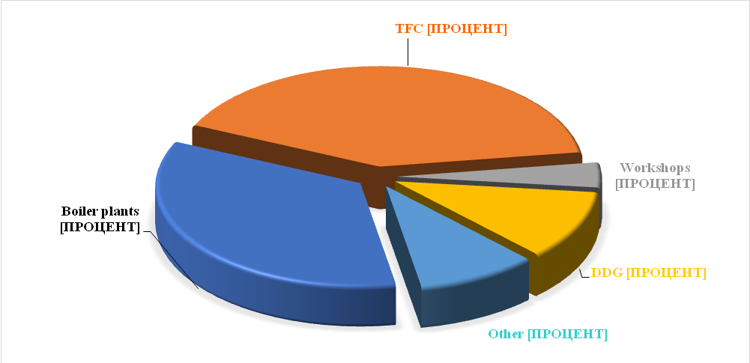
Figure 8.1 – The gross emissions of the Belarusian NPP in 2022, %

According to the permit for emissions of pollutants into the atmospheric air No. 04/12.7007 dated 06/16/2022, the allowable emission standard is 63.124278 tons/year. The actual gross emission of pollutants released into the atmosphere from stationary emission sources under the license in 2022 is 12.72 tons, i.e. 20.2% of the established regulatory value.
The dynamics of pollutant emissions in tons from the enterprise's boiler plants
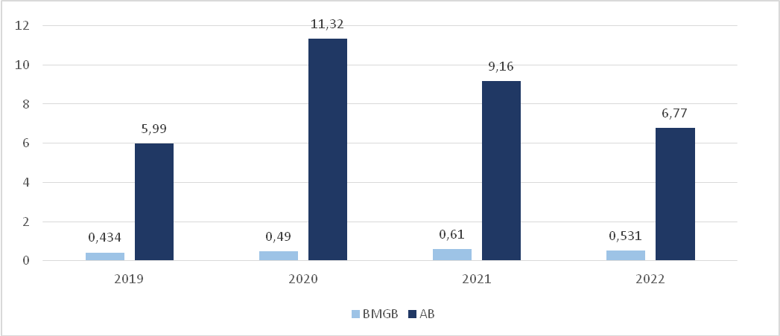
in comparison with previous years is shown on the Figure 8.2.
Figure 8.2 – Dynamics of pollutant emissions from the Belarusian NPP boiler plants, tons/year

The reduction in emissions from the AB compared to the previous year is due to the nature of the operation of power unit No. 1 of the Belarusian NPP, the AB was operated only during the period of preventive maintenance of the power unit.
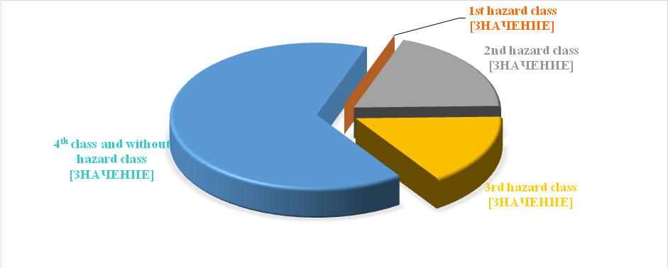
The emissions of the enterprise contain pollutants of 1-4 hazard classes, while the substances of the 1st hazard class amount to 0.0012 t, the substances of the 2nd class – 3.84t, the substances of the 3rd class – 3,19 t, the substances of 4th class and without hazard class – 14,14 t. The composition of pollutant emissions into the atmosphere by hazard class in 2022 is shown on the Figure 8.3.
Figure 8.3 – The composition of pollutant emissions into the atmosphere in 2022, %

In 2022 an analytical (laboratory) control of pollutant emissions from the following facilities was performed: AB, gas distribution plant and the BMGB. 19 measurements of pollutant emissions were carried out and 6 protocols of environmental protection measurement were prepared during the reporting period.
The maximum established value of one-time emissions for any of the pollutants were exceeded.
8.2. Industrial waste management
At the Belarusian NPP, in accordance with the Law of the Republic of Belarus dated July 20, 2007 No. 271-Z “On Waste Management”, the generated industrial waste are collected separately.
In 2022 an inventory of industrial waste was carried out, standards for the generation of production waste were developed, the “Guidelines for the management of industrial waste at the Belarusian NPP” was developed according to which the waste management is conducted and changes were made to the Permit for the storage and disposal of industrial waste.
During the reporting period, the enterprise generated 125 tons of industrial waste (in 2021 – 79,709 tons). By the end of 2022 6,62 tons of waste are in the interim storage, there were no mercury-containing.
The industrial waste classification by hazard classes for the current year is shown on the Figure 8.4.
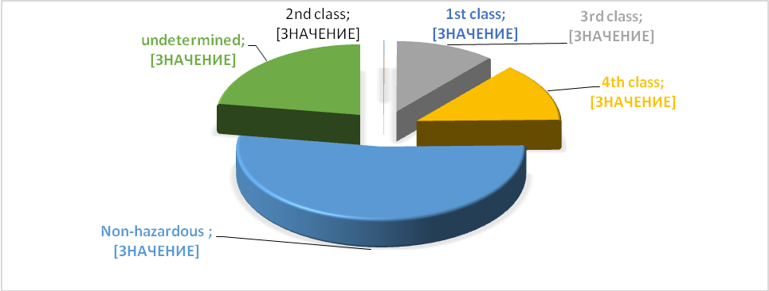
Figure 8.4 – Production waste classification by hazard classes for 2022, tons

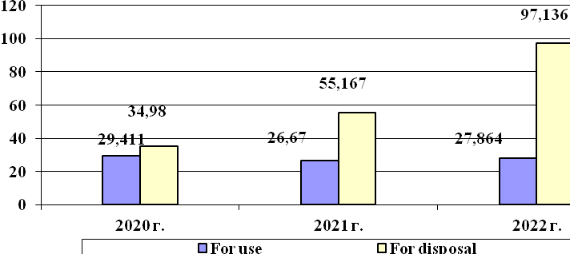
In the reporting year, industrial wastes were transferred to recycling and landfilling facilities in accordance with permits and concluded agreements, as well as to the interim storage sites. The share of secondary raw materials in the total amount of transferred waste amounted to 22,4 % (in 2020 – 51 %). The increase in the share of waste transferred for disposal is due to the commissioning of power unit No. 1 of the Belarusian NPP and the implementation of relevant production processes. Due to the exhaustion of the lamps of lighting devices, the amount of waste transferred for disposal increased (used mercury lamps, used fluorescent tubes, used compact fluorescent lamps (energy-saving)): in 2022 - 1460 pcs. (in 2020 and 2021 - 0 units). The dynamics of the production waste in comparison with the previous year in tons is shown on the Figure 8.5.
Figure 8.5 – Dynamics of the transfer of industrial waste for use and disposal, tons
During the operation of the Belarusian NPP in 2022, radioactive waste was generated (after preliminary sorting before processing) in the following quantities:
at the power unit No.1
- very low level waste – 67,797 m³;
- very low level solid radioactive waste – 33,431 m³;
- low level solid radioactive waste – 16,129 m³;
- medium level solid radioactive waste – 7,000 m³;
- high level solid radioactive waste – 0,065 m³.
at the power unit No.2:
- very low level waste – 6,44 m³;
- very low level solid radioactive waste – 1,96 m³;
- low level solid radioactive waste – 0,54 m³;
- medium level solid radioactive waste SRW – 0,02 m³.
After processing and containerization, solid radioactive waste was placed in a solid radioactive waste storage in the amount of 312 units of packages (barrels with a volume of 0.2 m³; capsules of incore detector assemblies with a volume of 0.05 m³) with a total volume of 62.25 m³.

8.3. Use and protection of water resources
Water consumption and water disposal was carried out in accordance with the limits established in the permit for special water use No. 04.12.0397 dated February 8, 2019, and did not exceed the design values.
The water consumption in 2022 compared to previous years is shown in Table 8.2.

Table 8.2 - Water consumption and water discharge at the Belarusian NPP in 2022
Indicator | limits established in the permit for special water use,  thousand m3/year | Amount,  thousand m³
Indicator |  | 2020 г. | 2021 г. | 2022 г.
1. The volume of produced (received) water, total | 70 682,2 | 5 527,435 | 29 567,801 | 29 537,837
2. Water used for household needs, total | 34 392,0 | 160,759 | 15 382,194 | 22 509,751
3 Water used for transferred to other organisations | 36 253,7 | 5 366,676 | 14 185,607 | 6 930,271
4 Volume of wastewater discharged into a surface water body | 31 781,3 | 4 155,151 | 19 176,558 | 21 998,004

The local monitoring is carried out at the 3 observation points (the point of wastewater discharge in the Viliya river, background and control sections at the Viliya river).
Analytical quality control of drinking and wastewater was performed by an accredited production laboratory of the plant's supporting systems department (Certificate of Accreditation No. 112 2.4928 dated May 19, 2017 till May 19, 2022). In addition to that third-party accredited laboratories were contracted to perform the full scope of observations.
In the period from January to December 2022, 24 studies of waste and surface water samples were performed at 3 local monitoring points and 96 protocols of measurements in the field of environment protection were registered.
During this period the laboratory studies of waste and surface water samples were carried out within the frames of local environmental monitoring for the following water quality indicators: pH value, water salt content, suspended solids, ammonium ion, total ferrum, potassium, calcium, magnesium, sodium, nitrate ion, nitrite ion, total phosphorus, total nitrogen, oil and oil products in dissolved and emulsified state, sulfate ion, phosphate ion, chloride ion, zinc, biochemical oxygen demand BOD₅ , chemical oxygen demand, dichromate oxidizability COD_{Cr} , synthetic anionic surfactants, aluminum, manganese, copper, lead, phenol, 1-hydroxyethylidene diphosphate (4-) zinc disodium salt (hydroxyethylidene diphosphonic acid zinc disodium salt; HEDP-Na₂ Zn; disodium salt of the zinc complex of hydroxyethylidene diphosphonic acid; ethanol-1,1-diphosphonate zinc disodium salt; ethylidene diphosphonic acid zinc disodium salt).
According to the observations no exceeding was identified in the reporting period.
8.4. Groundwater protection
In 2021 3 observation wells of the enterprise were included in the list of observation points for local environmental monitoring.
Groundwater monitoring in the vicinity of identified or potential sources of pollution includes 3 types of work: groundwater level monitoring; groundwater temperature monitoring; groundwater chemical composition. Chemical analysis included the identification of mineralization, water hardness, dry residue, free and aggressive CO2, О2 oxidizability, ions Cl-, SO42-, HCO3-, CO32-, NO2-, NO3-, NH4+, Ca2+, Mg2+, Na+, K+, Fe2+, Fetotal, рН, SiO2.
In the period from January to September 2022 were performed 3 studies of groundwater samples from 3 observation wells and 3 protocols for measurements in the field of environmental protection were drafted.
According to the observations no exceeding was identified in the reporting period.
8.5. Plant world
In 2022, a record of limited use of green areas on the territory of power unit No. 1 was compiled

8.6. Complex environmental monitoring
In 2021, complex environmental monitoring was carried out in the Belarusian NPP observation area and in sanitary-protection area.
Specialized accredited organizations of the Republic of Belarus and the Russian Federation were contracted to perform these work.
According to the environmental monitoring programmes of of the Belarusian NPP the following types of monitoring were carried out in 2021:
- monitoring of the groundwater dynamics;
- monitoring of atmospheric processes, phenomena and factors, including, weather and microclimate observations;
- aerological monitoring;
- observations of the surface waters dynamics;
- seismological monitoring;
- geodesic monitoring of the modern crustal movements;
- monitoring of ground-level air pollution, terrestrial and aquatic ecosystems, water bodies, the state of aquatic biological resources;
– radiation monitoring.
8.6.1. Groundwater monitoring
In 2022 the groundwater monitoring included three types of activities: groundwater level monitoring; groundwater temperature monitoring; groundwater chemical composition and its potential pollution. Chemical analysis included the identification of mineralization, water hardness, dry residue, free and aggressive СО2, О2 oxidizability, ions Cl-, SO42-, HCO3-, Ca2+, Mg2+, Na+, K+, Fe2+, Fetotal, рН, BOD5, CODCr.
The monitoring was performed on the properly equipped observation wells (piezometric observation network of wells consists of 26 well clusters) (fig. 8.6, 8.7).

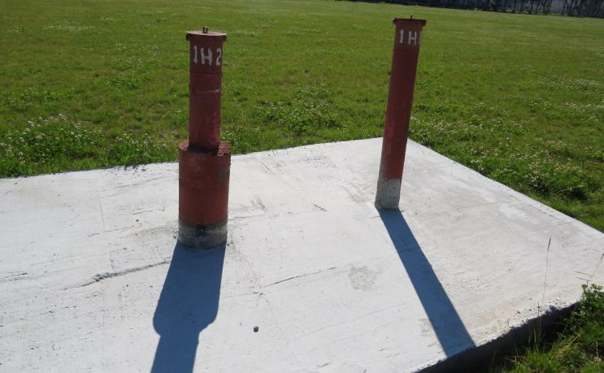
Figure 8.6 - Piezometric well cluster

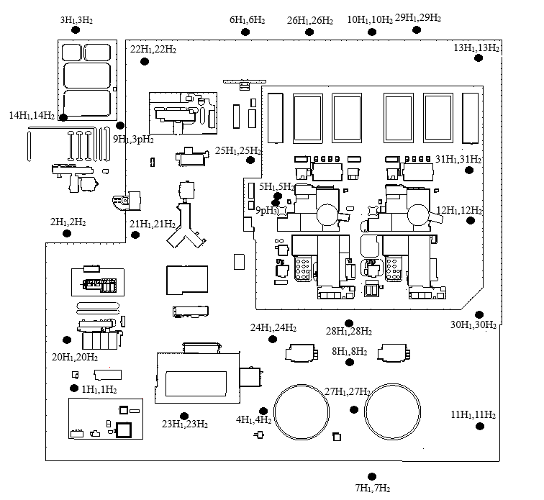
Figure 8.7 – Piezometric well clusters map

Groundwater dynamics was determined based on the results of groundwater monitoring in 2022.
The site has been and still remains in the groundwater transit and recharge area. Groundwater flow direction is the same during periods of maximum and minimum levels of. The groundwater level regime of observation wells in the territory of the Belarusian NPP generally correlates with fluctuations in the daily amount of precipitation recorded by the Markuny meteorological station (hereinafter referred to as the Markuny MS), which can be seen in Figure 8.8 and generally remains stable throughout the year (the average amplitude of fluctuations in during the year does not exceed 1 m). The water level in the observation wells located in the Sozh end-morainic aquifer H2 ranged from 156.79 to 164.60 m BS with an average value of 160.50 m BS. The amplitude of water level fluctuations in these piezometers during 2022 varied from 0.49 to 1.02 m with an average of 0.69 m. The water level in the only observation well installed in the Sozh end-morainic aquifer H3 insignificantly fluctuated during 2022 - within the absolute values ​​of 150.29–150.68 m BS with an average value of 150.51 m BS, the amplitude of fluctuations was 0.39 m. e dynamics of the groundwater level indicates the absence of “hydrogeological windows” in the site and in the adjacent territory, through which groundwater can be intensively recharged due to atmospheric precipitation infiltration and through which harmful chemicals enter the groundwater. In general, groundwater levels remain stable.
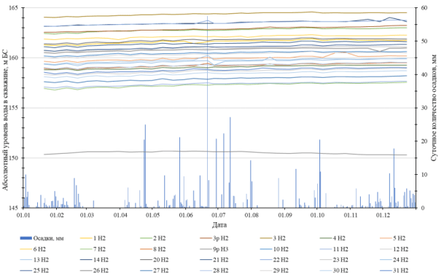
Figure 8.8 - Graph of the dependence of the level of groundwater on the amount of precipitation in 2022

The temperature conditions of groundwater from observation wells on the territory of the Belarusian NPP generally correlates with climatic factors (average daily air temperature), which can be seen in Figure 8.9. Thus, the groundwater temperature increased from May to November, as in the previous observation periods. The temperature of groundwater in observation wells located in the Sozh end-morainic aquifer ranged from 7.8 to 10.0°C with an average value of 8.8°C A regular increase towards the warm period and a decrease towards the cold period indicates the lack of nutrition due to the warmed waters of the water-bearing communications. By classification OST 41-05-263-86, groundwater from observation wells on the territory of the Belarusian NPP is characterized as cold all year round (the temperature does not go beyond the range of 4–20°C). In general, the temperature regime of groundwater remains stable.

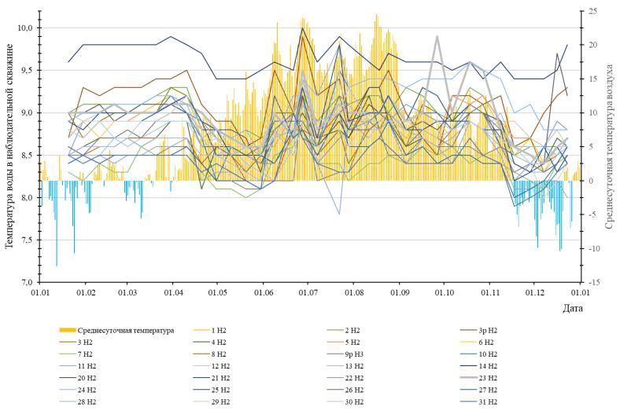
Figure 8.9 – Graph of dependence of groundwater temperature on air temperature in 2022

The waters of the observation wells are characterized by pH from neutral (7.4 pH) to alkaline (10.0 pH), by mineralization - they are all fresh (less than 1 g/l), by hardness - from very soft (0.9° W) to hard (7.3°F), which coincides with indicators of 2021. The content of aggressive and free carbon dioxide in the selected groundwater samples did not exceed 8.8 mg/l; in most samples, the values ​​of these indicators were not found at all. The oxidizability of the samples taken during the year ranged from 0.04 to 8.48 mgO₂/dm³, averaging 1.13 mgO₂/dm³ per year. BOD and COD values ​​ranged from 0.03 - 5.48 (0.724) and 1.01 - 79.25 (22.85), respectively. Bicarbonates predominate in the anionic composition of groundwater samples. Fluctuations in the values ​​of the content of determined anions during 2022 are amounted to: hydrocarbonates 24.41 - 283.70 mg/l; chlorides 4.26 - 134.78 mg / l; sulfates 0.57–56.38 mg/l; carbonates 12.0 mg/l. The cationic composition of groundwater samples is dominated by calcium and magnesium cations. Fluctuations in the values ​​of the content of determined cations during 2022 amounted to: calcium 4.01 - 95.68 mg/l; magnesium 6.80 - 65.25 mg / l; sodium 2.06 - 38.2 mg / l; potassium 0.67 - 8.4 mg / l; iron 0.39 - 54.45 mg / l. The results of groundwater chemical monitoring for 2022 are presented in Table 8.3.

Table 8.3 – The results of groundwater chemical monitoring in 2022
№ | Indicator | Results for 2022 |  |  | Results received before the Belarusian NPP construction (2013 year)
№ | Indicator | Average | Min* | Max* | Average | Min* | Max*
1 | Bicarbonate ion (mg/dm ³) | 151,92 | 48,80 | 211,99 | 177,81 | 64,10 | 305,00
2 | Chloride ion (mg/dm³) | 29,04 | 4,43 | 101,79 | 28,64 | 17,20 | 49,30
3 | Sulfate ion (mg/dm³) | 14,28 | 3,07 | 28,23 | 19,71 | 2,50 | 46,9
4 | Nitrate ion (mgN/dm³) | 0,20 | 0,20 | 0,20 | 35,41 | 1,30 | 60,80
5 | Nitrite ion (mgN/dm³) | 0,21 | 0,20 | 0,35 | 0,08 | 0,01 | 0,50
6 | Carbonate ion (mg/dm³) | 6,65 | 4,50 | 12,00 | 7,07 | 3,00 | 18,00
7 | Calcium (mg/dm³) | 34,63 | 14,60 | 59,84 | 43,52 | 7,40 | 84,00
8 | Magnesium (mg/dm³) | 23,06 | 10,78 | 40,03 | 17,46 | 3,90 | 27,60
9 | Ferrum general (mg/dm³) | 10,71 | 2,57 | 20,27 | 1,48 | 0,05 | 8,50
10 | Ammonium ion (mgN/dm³) | 0,89 | 0,50 | 2,95 | 2,37 | 0,10 | 7,00
11 | Potassium + Sodium (mg/dm³) | 7,86 | 4,09 | 27,38 | 18,25 | 3,60 | 138,00
12 | Mineralization (mg/dm³) | 250,98 | 129,01 | 453,36 | 334,71 | 170,00 | 530,00
13 | Hydrogen indicator (рН) | 8,28 | 7,87 | 8,93 | 7,57 | 6,92 | 8,98
* Estimated value received by averaging the absolute minimum (maximum) values ​​of the indicator for all observation wells.

The waters of all wells, on average in 2022, are characterized as hydrocarbonate magnesium-calcium.
The pollution of groundwater with anthropogenic pollutants (NO3 and Cl) remains at the pre-construction level and is due to agricultural activity in the area near the nuclear power plant. They continue to arrive at the site as transit from adjacent territories. In general, during the monitoring period, the chemical composition of groundwater remains relatively stable. Surface contamination of groundwater due to the technological cycle of the Belarusian NPP, was not identifie.

8.6.2. Monitoring of meteorological processes, phenomena and factors In 2022 meteorological parameters monitoring were taken 8 times per day by the meteorological station (hereinafter – MS) Markuny, and a number of other special observations were performed: gradient observations of air temperature and humidity, wind speed at heights of 0.5 and 2 m; observations of ice and frost, measurements of deep soil temperature, observations of evaporation from the water surface (fig. 8.10 and 8.11)
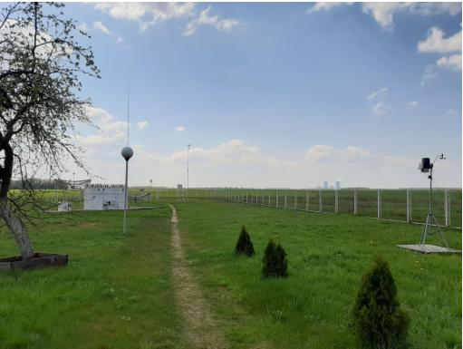
Figure 8.10 - Markuny meteorological station

In 2022 the average air temperature according to the MS Markuny was 7.3°C, and the soil temperature was 9.1°C. The coldest month of 2022 was December with an average monthly air temperature of - 3.4°C, the hottest was August with an average temperature of 19.9°C that is due to the influence of the blocking anticyclone and the heat wave in August 2022 on the weather. The absolute maximum air temperature equal to 31.2°С was noted on August 24, and the absolute minimum was observed on January 24 and amounted to minus 17.7°С.
The average relative humidity for the year is 81%. Average monthly values ​​of relative air humidity varied from 68% in March to 93% in December. The lowest value of relative air humidity was noted in August and was equal to 17%. The largest number of days with relative air humidity above 80% within 15 hours was observed in November and December and amounted to 25 and 28 days, respectively. The diurnal march of relative air humidity in all months tends to decrease in the daytime with minimum values ​​at 15:00 local time. From March to September, relative air humidity and saturation deficit have a pronounced diurnal march, in other months it is smoother.
Saturation deficiency and water vapour partial pressure repeat the course of the average monthly air temperature and grow from winter to summer, reach the maximum average monthly values ​​in August (8.5 and 16.8 mb, respectively) and again decrease by the end of the year to values ​​of 0.3 for saturation deficiency and 4.6 mb for the partial pressure of water vapor.
During 2022, the average daily pressure at MS Markuny varied from 990.0 hPa to 1007.4 hPa and average value is 996.5 hPa. The highest atmospheric pressure was noted on October 8 and amounted to 1029.3 hPa, the lowest - 957.1 hPa on February 17.
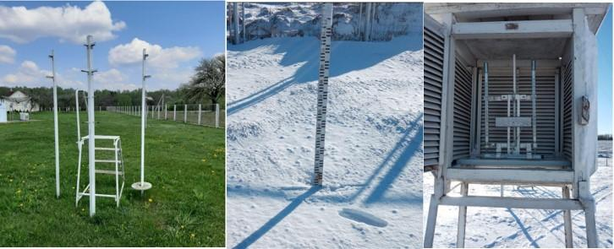
Figure 8.11 – Measuring tools at the Markuny meteorological station

In total, 254 days with precipitation were noted during the reporting period. During the year, 628 mm of precipitation fell, of which most of them in the period from May to September - 314 mm. The maximum daily layer of precipitation was observed on June 21 and amounted to 57.5 mm. Showers with an intensity of more than 30 mm/h were not observed. The amount of solid precipitation exceeding the intensity of 20 mm per 24 hours was not observed during the entire observation period. In 2022, ice events were observed at the MS Markuny 9 times, of which 6 were crystalline hoarfrost, 2 were glaze, and 1 was wet snow buildup.
During the year, winds of northwestern, western rhumbs were prevailed. The eastern winds have the lowest frequency (Fig. 8.12).
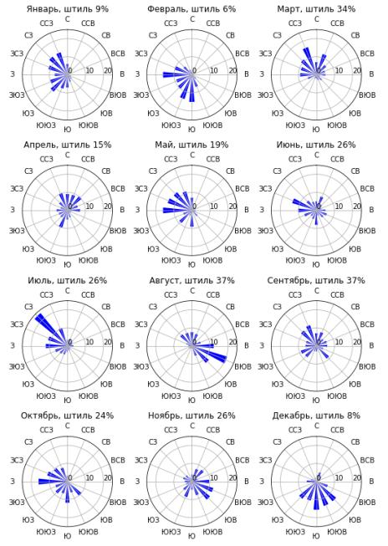
Figure 8.12 – Wind roses according to MS Markuny
for January - December 2022

The average wind speed for 2022 is 2.5 m/s, with the highest monthly averages in January (4.0 m/s) and February (4.3 m/s). The wind speed during the day decreases in the early morning hours, and the highest speeds are most often observed in the afternoon.
Winds with a speed of 2-3 m/s during the year amounted to more than 40 %, cases of calm and winds with a speed of 1 m/s were most often observed in the summer months, in general for the year they amounted to 30 %. Winds with speeds above 4 m/s during the periods from January to May and from October to December account for more than 30 % of the total frequency. In April, May, October, November and December, winds were observed at a speed of 10-11 m/s, but their frequency does not exceed one percent. The highest frequency of weak winds up to 2 m/s was observed in August and amounted to 89 %, the lowest - in February – 11 %.
The lowest wind was in August ,with an average monthly speed of only 1.5 m/s. The maximum wind speed in a gust between the dates in January and February 2022 was 24.0 m/s (January 14 and February 19), in March it took the value of 23.0 m/s (March 28), in April 21 m/s (April 5), in May was equal to 17.0 m/s (May 12). In June, the maximum speed in a gust was 16 m/s (June 14), in July 17 m/s (July 12), in August and September it was 11.0 and 12 m/s (August 13 and September 16), in October and November - 12-13 m/s (October 30 and November 12), in December 14 m/s (December 8).
The wind speed in the study area has a clear intra-annual course of average monthly speeds. The highest wind speeds are observed in the cold period of the year (December - March). In subsequent months, the wind speed gradually decreases, reaching the lowest values ​​in June-August. In the future, the wind speed gradually increases. Such a course of wind speed is associated with cyclonic activity, which intensifies in the autumn-winter period, and at the end of summer the depth and frequency of cyclonic formations decreases.
The available values ​​of meteorological characteristics according to the MS Markuny for the period 2015-2022 are still insufficient for conclusions about climatic conditions in the study area, and we can only talk about updating the extreme values ​​of meteorological characteristics.
The air temperature over the eight-year averaging period for the MS Markuny is slightly higher than the long-term average values ​​for the MS Oshmyany and Lyntupy (Oshmyany, MS Lyntupy). For example, the average annual air temperature at the Markuna MS for the period from 2015 to 2022 was 7.8°С, which is 0.6°С and 0.4°С higher than the long-term average air temperature at the MS Lyntupy and MS Oshmyany, respectively.
The relative humidity over the eight-year averaging period at the Markuny MS is very close to the long-term values ​​at the MS aOshmyany nd MS Lyntupy and amounts to 80%.
Average annual precipitation for the period 2015-2022 at Markuny MS is 696 mm, which is 60 mm more than at MS Oshmyany and 53 mm less than at MS Lyntupy.
The annual average wind speed is characterized by a decrease in speed in the summer months and an increase in the winter. Against the background of global trends, according to the data of surface meteorological observations, the average wind speed at MS Markuny observed over an 8-year period is 2.5 m/s, at MS Oshmyany - 3.1 m/s, at Lyntupy MS - 2.0 m/s. The difference in average annual wind speeds for a pair of MS Markuny - MS Lyntupy is 0.5 m/s, for a pair of MS Markuny - MS Oshmyany the difference is negative - minus 0.6 m/s.
8.6.3. Microclimate monitoring
In 2022 microclimate monitoring was performed in the area of the Belarusian NPP. Microclimate monitoring was carried out at 10 points of the two sections. One section of Chekhi - Bobrovniki is aligned from east to west, the other Mikhalishki - Chekhi is from north to south (Fig.8.13). The monitoring has been performed 2 times a day at 06:00 and 18:00 at 5 points of each section.
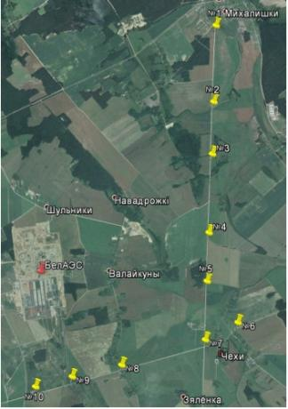
Figure 8.13 – Map of microclimate monitoring points

According to the monitoring results, the combined graphs of the air temperature curves demonstrated that the air temperature at the markers and at the MSLyntupy, MS Markuny are almost the same (the difference between the values does not exceed 0.8°C in average).
The combined curves of the air temperature at the markers showed: that during the monitoring of 2015 - 2021 the lowest air temperatures were fixed in January 2016: - 9.6 °С (morning) and - 7.4 °С (evening); the highest air temperatures were recorded in the evening in July 2021 (25.5 °С) and in the morning in July 2018 and July 2021 (16.5 °С). The winter of 2019-2020 (December 2019 and January, February 2020) can be classified as abnormally warm, since the air temperature had positive values (above 0.0 °С) (Fig. 8.14).
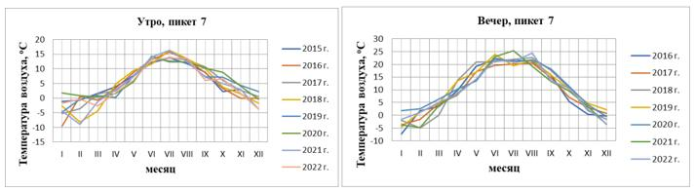
Figure 8.14 – Combined curves of the air temperature at marker 7 during the period of 2015-2021.

The combined curves of relative air humidity demonstrated that the values ​​of relative air humidity at meteorological stations are predominantly higher than at the markers. The lowest values ​​of relative air humidity were in March (in the morning at MS Oshmyany - 81% and in the evening at MS Lyntupy - 43%).
Combined curves of relative air humidity at the markers during 2015–2021 demonstrated that the driest month in the morning (with the lowest relative humidity) was September 2018 (60% relative humidity). The driest evening values during the entire monitoring period were observed in April 2019 (38 % relative humidity). Accordingly, the wettest month in the morning is July 2022 (95 %), in the evening - November 2020 (93 %). The highest average annual relative air humidity in the morning was observed in 2020 (91 %), and the lowest average annual relative air humidity in the evening of observation was in 2022 (68%) (Fig. 8.15).

Figure 8.15 - Combined curves of the relative air humidity at marker 7 during 2015-2021
The combined curves of the wind speed demonstrated, that at the MS Oshmyany the wind speed values ​​both in the morning and in the evening are higher compared to other observation points. Despite the fact that the wind speed values ​​at weather stations and markers fluctuate among themselves during the entire observation period, the dynamics of these fluctuations is of the same type. In general, the wind speed at pickets is lower than at weather stations.
The combined curves of the wind speed at the markers demonstrated: during 2015-2021 the highest wind speeds were fixed in the morning in February 2020 (3.1 m/s) and in the evening in March 2019 (4.3 m/s) (Fig. 8.16).

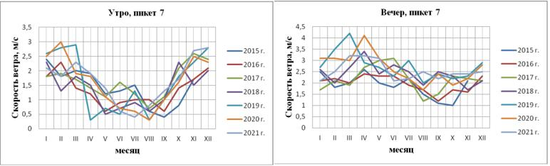
Figure 8.16 – Combined curves of the wind speed at marker 7 during 2015-2021.

For an eight-year observation period, the results of the main microclimatic parameters (air temperature, wind speed, relative air humidity) were obtained, which are the criteria that determine changes in the microclimate. However, it should be noted that the existing database of observations is still not enough to perform statistical processing and assess microclimate changes in the area of ​​the Belarusian NPP. Monitoring of microclimatic parameters will be continued.
8.6.4. Aerological monitoring
The aerological monitoring of the atmospheric boundary layer status (hereinafter referred to as ABL) at the MS Markuny was performed in 2022. Observations were carried out using the SODAR / RASS measuring complex (fig. 8.17).
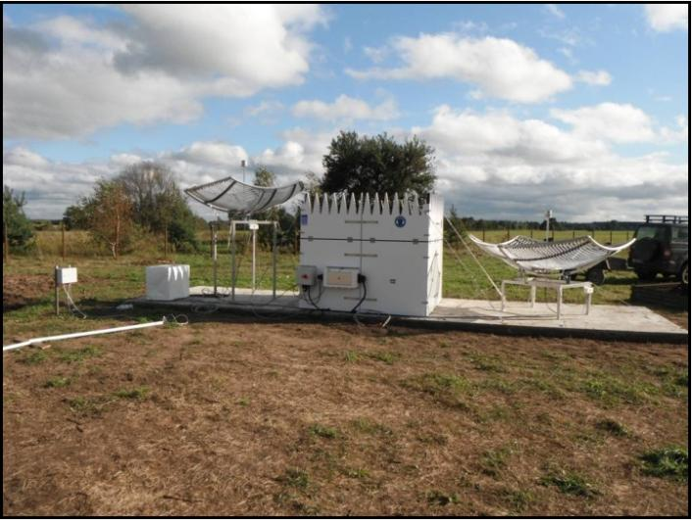
Figure 8.17 – SODAR measuring complex

The results of observations for 2022 demonstrated that vertical temperature gradients and temperature inversions indicate the presence of retardant layers in ABL and provide a qualitative description of the conditions for impurity dispersion. On average, over the year, the vertical temperature gradient is positive and varies for layers 0–300, 0–600 and 0–900 m within 0.63–1.42°C/100 m. Elevated inversions predominate among the different types of inversions. The total frequency of the negative stability classes (E and F) is insignificant and in general amounted to only about 5,1% during a year.
The calculated data show that the most negative conditions for the pollutant ventilation in the ABL can affect the environment and the population at all stages of the NPP life cycle in spring. However, even in these periods the occurrence of the negative stability classes E and F is insignificant.
The average wind velocity is moderate and in general winds of the south-western directions prevail throughout the year (Fig. 8.18).

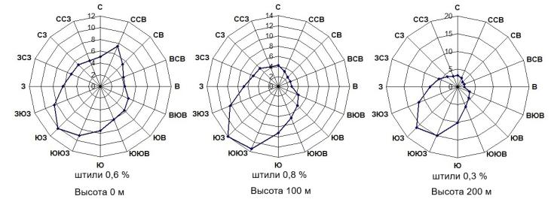
С | ССВ | СВ | ВСВ | В | ВЮВ | ЮВ | ЮЮВ | Ю | ЮЮЗ | ЮЗ | ЗЮЗ | З | ЗСЗ | СЗ | CCЗ
N | NNE | NE | ENE | E | ESE | SE | SSE | S | SSW | SW | WSW | W | WNW | NW | NNW

Figure 8.18 – Average wind roses in 2021

Data of remote zoning of the ABL status accumulated over 7 full years makes it possible to identify the patterns of year-to-year changes in the atmospheric dispersion features. According to the data for 2015-2022 it can be stated that the temperature lapse rate is positive and varies within 1.31-1.89 C/100 m. This pattern of temperature lapse rate indicates significant ABL turbulence, which contributes to intense dispersion of radionuclides. Classes B, C and D prevail during the entire observation period, which confirms favorable conditions for the dispersion of radionuclides. The wind increases strongly on vertical gradient and its speed typical values vary within 1-5.5 m/s. In the long-term prospective the year-to-year variations of the wind speed are insignificant and commensurate with the accuracy of its measurement. The winds of the west-southwest direction prevail during the entire period of monitoring.
Thus, in general, during the period 2015-2022 there is a relative year-to-year stability of the main average annual atmospheric dispersion features.
8.6.5. Surface water observations
The level, runoff, ice, thermal regimes and water turbidity was observed in the rivers of Viliya, Stracha, Gozovka and Polpe in 2022. No dangerous hydrological phenomena were observed at the Belarusian NPP area location and area of water catchment area of Vilia river during 2022 (Fig. 8.19).
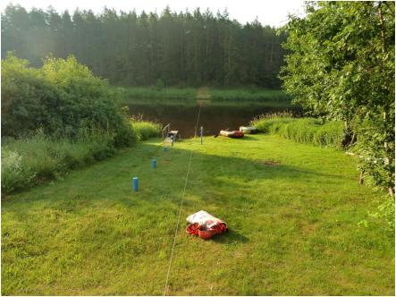
Figure 8.19 - Water gauge station

Based on the level regime monitoring in 2022 it was revealed that the water level of the Viliya river near the settlement of Malye Sviryanki varies from 2.05 m BS (September 09-11, 2022) to 3.18 m BS (February 22-23, 2022). The average water level in 2022 was 2.51 m BS (Fig. 8.20).

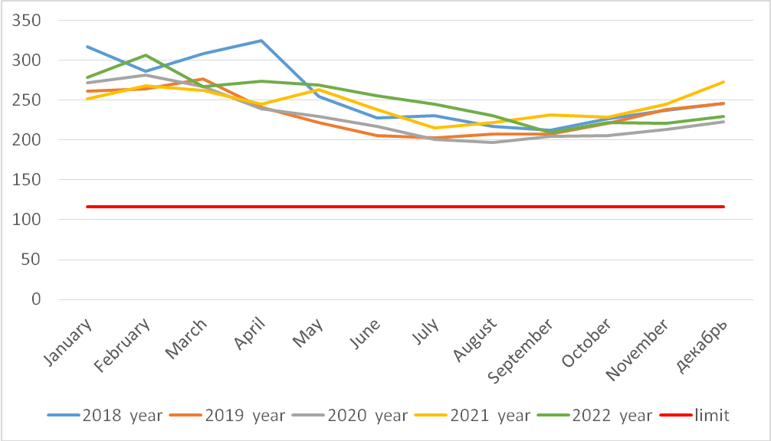
Figure 8.20 – Water level measurement at the water gauge station of the Viliya river (settlement Malye Sviryanki) in 2018-2022, mBS

It should be noted that the maximum and minimum values ​​of the level of the Viliya river, measured in 2022, did not go beyond the calculated parameters taken as the design values.
In general, the level regime on the studied rivers in 2022 was characterized by a small amplitude during the year, which was within the measurement range of previous years of observations; there were low flood levels and a predominance of rain floods.
According to the results of observations of the temperature regime in 2022, it was revealed that the water temperature of the Viliya river near the settlement Malye Sviryanki changed from 0°C (December 19-20, 2022) to 24.5°C (July 1, 2022). The average water temperature for 2022 was 9.2°C (Fig. 8.21).
It should be noted that the maximum values ​​of the water temperature of the Viliya river, measured in 2022, did not go beyond the calculated parameters taken as the design basis.
In general, the temperature regime on the studied rivers in 2022 was within the measurement range of previous years of observations.
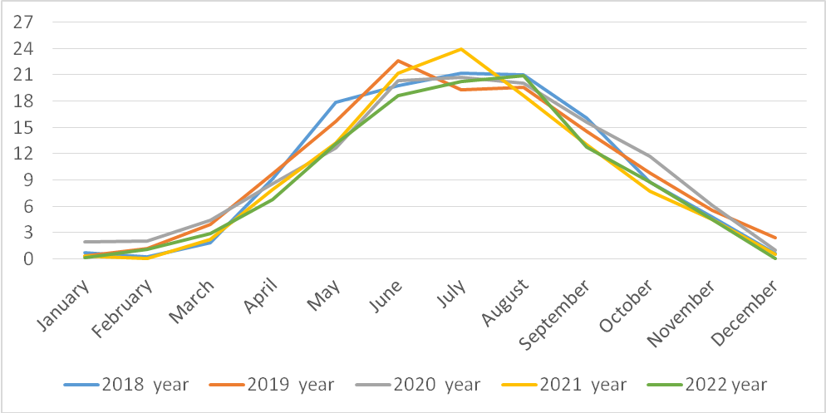
Figure 8.21 – Water temperature measurements at the water gauge station of the Viliya river (settlement Malye Sviryanki) in 2018-2022, °С

The runoff regime observations in 2022 demonstrated that the water flow in the Viliya river in the settlement of Malye Sviryanki varied from 34.5 m³/s (September 09-11,2022) to 158 m³/s (February 22,2022). The average water consumption in 2022 was 57,5 m³/s (fig. 8.22).
The fluctuation of water flow data is due to the natural processes (start of the spring flood, meteorological event).
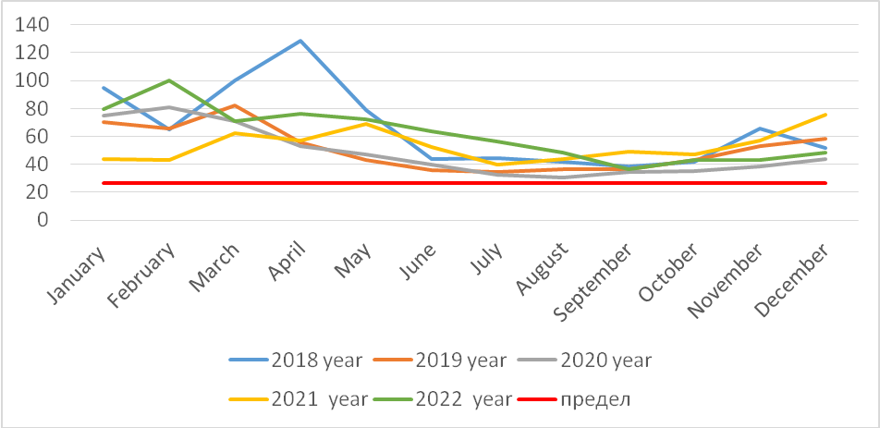

Figure 8.22 – Water consumption measurements at the water gauge station of the Viliya river (settlement Malye Sviryanki) in 2018-2022, m³/s

According to the results of observations of the ice regime in 2022, it should be noted that the winter of 2020-2021 characterized by unstable ice phenomena. So, on the Viliya river in late December and early January, unstable shore ice and a rare frazil ice drifter were observed.
Winter 2021 – 2022 was characterized by the absence of stable ice phenomena at all hydrological stations, due to the absence of prolonged negative air temperatures.
Winter 2022 – 2023 – unstable ice phenomena appeared in mid-December, on the Viliya river a rare frazil ice drifter and unstable shore ice were observed. In general, winter 2022-2023 it is also characterized by the absence of stable ice phenomena at all hydrological posts, due to the absence of prolonged negative air temperatures.
According to the observation results in 2022 the Viliya river flow rate near settlement of Malye Sviryanki changed from 0.58 m/s (September 21,2022) to 0.79 m/s (June 30,2022). The Viliya river average flow rate in 2022 was
0.66 m/s.
At all phases of the hydrological regimen in 2022 the water samples were obtained at four water gauge stations (Viliya river, Stracha river, Gozovka river, Polpe river) to analyze the chemical composition including the following indicators: physical properties of water, suspended solids, hardness, water-dissolved gases, pH, principal ions, biogenic substances, Si, Fe, biochemical oxygen demand (5 days), oil products, synthetic surfactants, phenols, heavy metals, pesticides.
According to the analysis results the river waters are classified as weakly alkaline (based on the A.M. Nikanorov classification), the pH varied in the range from 7.03 to 8.21.
The oxygen regime remained favorable for the sustainable functioning of watercourse ecosystems. The content of dissolved oxygen corresponded to the established quality standards and varied from 7.22 mgO₂/dm³ to 12.22 mgO₂ dm³.
The content of easy oxidizable organics (BOD₅ - the amount of oxygen consumed during the biochemical oxidation within 5 days period) did not exceed the quality standards established for watercourses. The content of hardly oxidizable organic substances (according to COD_{Cr}), the main biogenic substances (nitrogen and phosphorus compounds) met the quality standard in the water of all the studied watercourses.
8.6.6. Seismological monitoring
Monitoring of the seismic parameters in the vicinity of the Belarusian NPP is based on a temporary local observation network (7 monitoring points of the local seismic network: “Vadatishki”, “Gradovshchizna”, “Boyary”, “Selishche”, “Vorobyi”, “Gornaya Kaimina” and “Litvyany”). This local network operates 24/7 with continuous recording of signals emitted by natural and artificial sources of seismic vibrations, registering seismic events in a wide range of epicentral distances and power (Fig. 8.23).

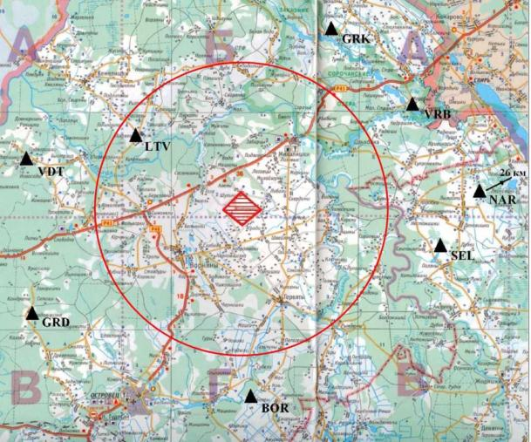
Figure 8.21 - Layout of seismic stations in the vicinity of the Belarusian NPP
Legend:
▲ - seismic stations: Boyary - BOR; Gradovshchizna- GRD; Vadatishki - VDT; Selishche - SEL; Vorobyi - VRB; Gornaya Kaimina - GRK; Livtiany - LTV; Naroch - NAR. - perimeter of the Belarusian NPP site.

During the reporting period the distant, regional and nearby earthquakes, as well as man-made seismic events (explosions) were recorded based on the data from the network. There were no local events registered within the 30 km area around the NPP site during the reporting period.
The catalog of distant earthquakes for a year period contains data of 181 earthquakes of magnitude М≥6.0. The catalog of regional earthquakes for a year period contains data of 108 earthquakes. The catalog of nearby earthquakes (R = 30–300 km) for a year period contains data of 26 earthquakes. The catalog of man-made seismic events for a year period includes 146 explosions.
In 2022 the earthquakes in the vicinity of the NPP were registered in the southern part of Belarus (Salihorsk mining area), epicentral distance of which is 200 to 300 km to the site of the Belarusian NPP. These earthquakes epicenters are located in the Pripyat non-linear seismogenic superzone of the possible earthquake sources (PES) which is the most extensive and active geodynamic structure within Belarus. This superzone includes a number of zones, which are subdivided into subzones. North Pripyat seismogenic zone (Luban, Berezinsky and Gomel subzones), Central Pripyat seismogenic zone and South Pripyat seismogenic zone (Slovechno and Turov subzones). The main factor for identifying the Pripyat superzone of the PES was its confinement to the Pripyat-Dnieper-Donetsk paleorift seismotectonic province. Similar structures have increased seismicity on other ancient platforms. Strong earthquakes usually occur in the marginal parts of the structures, weaker ones, in the central part of the downwarping. They are mainly associated with longitudinal faults, fragments of which are active at the latest stage of tectonic development. The concentration of sources of nearby earthquakes (in the 300 km zone from the site of the Belarusian NPP) is observed in the northwestern part of the Pripyat superzone. The epicenters of nearby earthquakes are located in the Central Pripyat seismogenic zone and two seismogenic subzones of Luban and Berezinskaya. Seismotectonic potential of the Central Pripyat seismogenic zone (Mmax ​​= 3.5; h = 5 km; I = 4–5 points). Seismotectonic potential of two seismogenic subzones: Luban (Mmax ​​= 4.0; h = 5 km; I = 5 - 6 points) and Berezinsky (Mmax ​​= 4.5; h = 10 km; I = 6 - 7 points).
The magnitude range of the registered earthquakes in the vicinity of the NPP in 2022 is М=1.1–2.9, which does not exceed the seismotectonic potential of the PES, where their epicenters are located.
The earthquakes that had the greatest seismic impact on the NPP site in 2022 have the following parameters. The maximum acceleration and the maximum intensity data was obtained for a remote earthquake of 5.1 magnitude in Cyprus on January 11, 2022, which amounted to 0.0691 cm/sec²
(0.69×10⁻⁴g) and with rated value of 1.1 (fig.8.24).
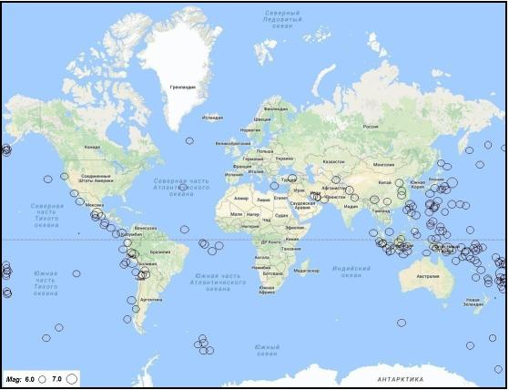
Figure 8.24 – Map of epicenters of distant earthquakes with M ≥ 6.0, registered for the annual cycle of observations in 2022

The maximum acceleration and the maximum intensity data was obtained for a regional earthquake of 4.9 magnitude in Poland on April 07, 2022, which amounted to 0.0554 cm/sec² (0.55×10 ⁻⁴g) and with rated value of 0.3 (fig.8.25).

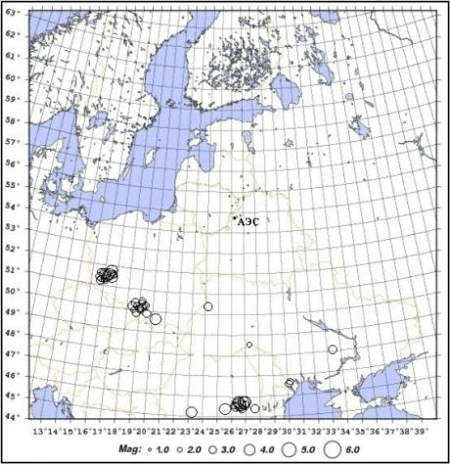
Figure 8.25 – Map of epicenters of regional earthquakes registered for the annual cycle of observations in 2022

The maximum acceleration and the maximum intensity data was obtained for a nearby earthquake of 2.2 magnitude in Belarus on December 12, 2022, which amounted to 0.0439 cm/sec² (0.44×10 ⁻⁴g) and with rated value of 2.1 (fig.8.26).

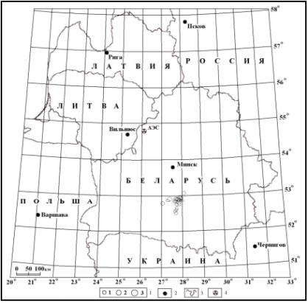
1 – magnitude, 2 – CITY, 3 – state boarder, 4 – Belarusian NPP
Figure 8.26 – Map of epicenters of nearby earthquakes registered for the annual cycle of observations in 2022

The value of maximum acceleration (PGA) up to 0.44 in accordance with the National Standard of the Russian Federation "Scale of seismic intensity" (Moscow, 2017, p. 16, tab. B.1) does not exceed the seismic intensity of 1 point. This is the smallest value. In the works of V.I. Ulomov, a similar value is 1.5 cm/sec², and in the work of F.F. Aptikaev, this value is 0.7 cm/sec² (Instrumental scale of seismic intensity. Moscow: Nauka i obrazovanie, 2012, 176 pages).
Thus, in 2022, the maximum values ​​of the intensity of the seismic impact on the site of the Belarusian NPP were from a distant earthquake that occurred near the island of Cyprus with a magnitude of 6.5 and amounted to: peak acceleration of 0.0691 cm/sec² (0.69×10⁻⁴ g), rated value of 1.1.
The results of calculating the intensity of seismic impacts on the Belarusian NPP site from distant, regional and nearby earthquakes recorded by the local seismic network for 2022 demonstrated that they are significantly lower than the design level values, which are 6 points for a design basis earthquake (DE), for the maximum design earthquake ( MDE) - 7 points.

8.6.7. Geodetic monitoring of the modern crustal movements
Monitoring of the modern crustal movements includes determination of the horizontal and vertical component of movements.
In 2022 the horizontal crustal movements were monitored on the basis of the GPS technology method. The modern satellite geodetic technologies (GPS measurements) to determine points location in different periods of time made it possible to determine the horizontal shifts with a millimeter accuracy. Space geodesy methods are an order of magnitude higher in accuracy than measurements made by classical geodesy methods, and have greater productivity, allow observations at remote points without taking into account mutual visibility, are distinguished by high metrological characteristics, all-weather measurements, and highly developed processing software.
The satellite geodetic network was created at 18 points, of which 15 are deep benchmarks, 1 ground benchmark and 2 points with a forced centering device (tours).
Field measurements of the geodynamic area were carried out once a year.
According to the monitoring for 2022 it was revealed that the average annual rate of horizontal crustal movement ranged from 20.4 to 28.7 millimeters per year, where average value of 23.9 millimeters per year does not exceed the accepted tolerance. The average direction of movement is to the northeast along the azimuth of 56°.
For the period 2012-2022 (10.23) the speed of the horizontal crustal movement points are in the range of 24.5 - 25.8 millimeters per year, when average estimated value is 25.0 millimeters per year. The average shifts direction by cycles is to the northeast azimuth of 57°(Fig. 8.27, 8.28 ). The velocity gradients of horizontal movements in the observation area, as a change in the amplitude of movement per unit of distance per unit of time, ranged from 7×10⁻⁹ to 2×10⁻⁷ 1/year (Fig. 8.29).
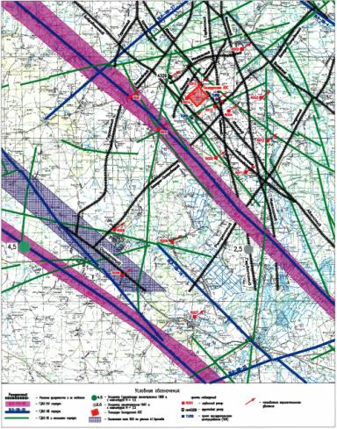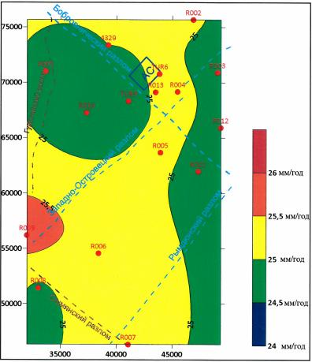

Figure 8.27 – Directions of horizontal crustal movement within the period of 2012-2022
Figure 8.28 - Distribution of the rates of horizontal crustal movement recorded within the period of
2012-2022

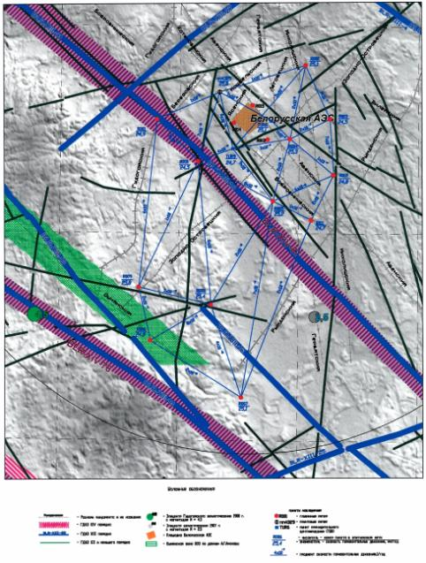
Figure 8.29 – Scheme of horizontal motion rates and velocity gradients within the period of 2012-2022

The design of the Belarusian NPP contains critical thresholds for modern movement, which is 50 millimeters per year for horizontal shifts. The rate of shifts measured in the study area does not exceed these values.
An analysis of the observations of the horizontal crustal movements in 2022 suggests that the values and direction of horizontal movements at the geodynamic area of the Belarusian NPP coincide with the general movements of the East European Platform. Insignificant discrepancies in the speeds and directions of movement of points cannot indicate the presence of any local horizontal movements in the study area.
In 2022 the vertical crustal movements were observed using high-precision leveling of the Class I.
Geometric leveling of the geodetic points of the geodynamic network according to the method of I Class performed in order to determine the vertical amplitude of the movements of the earth's surface. Class I leveling was performed in the forward and reverse directions, while observing the equality of distances from the level to the rails along two pairs of transition points, which formed two separate lines. Measurements at observation points were carried out once a year.
The total length of the network is 142,60 km. There are 14 separate lines between points, which form 6 closed areas, average perimeter of which is 31.1 km (tolerance 40 km). The network is fixed with 13 deep benchmarks, 40 ground benchmarks, 8 wall marks, 3 TUR-type centers and 3 temporary benchmarks. The total number of points is 67.
Analysis and evaluation of the monitoring of vertical crustal movements and velocities for 2022 showed that the velocities of vertical movements of points ranged from (-1.0) to (-3.0) millimeters per year. Consequently, the rates of vertical shifts of the points of the geodynamic area are within acceptable limits (do not exceed 10 millimeters per year). The general gradient of the shift rate of the geodynamic area ranged to 3.0 × 10⁻⁸ 1/year.
Based on observation data for 2012 - 2022 the general values of the vertical rate of movement of the geodynamic area points ranged from (-0,46) to (+0,07) millimeters per year. In the area of the NPP the rate of movement ranged from 0.0 to (-0.1) millimeters per year.
Weighted average values of inter-cycle shifts of the network points range from (+0,33) to (-0,94) millimeters per year (Fig. 8.30).
The vertical movements velocity gradients in the observation area were ranged from 1,3×10⁻⁹ to 1,6×10⁻⁷1/year. general gradient of the shift rate of the geodynamic area ranged from 1,9×10⁻⁸ to 4,9×10⁻⁸ 1/year. The direction changes slightly, which indicates the absence of geodynamic processes for the reporting period (fig.8.31).
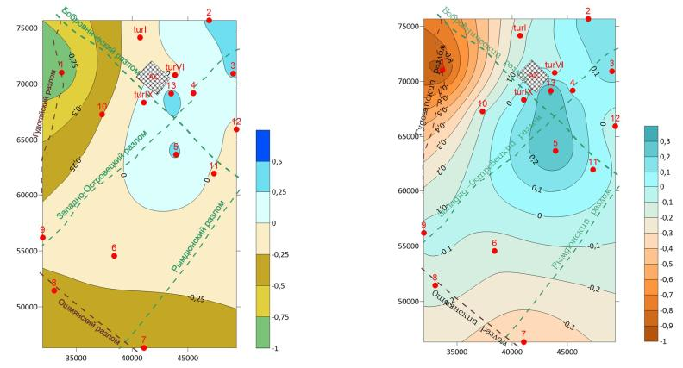
а) б)
Figure 8.30 - Distribution of weighted average values of vertical movements of points and velocities in the period of 2012 - 2021

a) vertical movements of points
b) average annual rates of movement

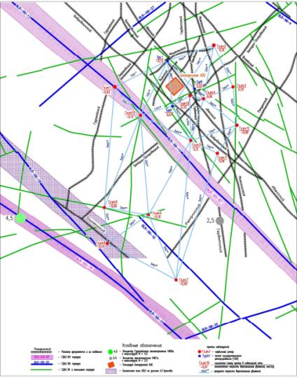
Figure 8.31 –Velocity gradients of vertical movements at the geodynamic area of the Belarusian NPP in the period of 2012 - 2021

Based on the data obtained it should be concluded that the directions, distances and stability criteria of geodynamic monitoring points are stable, the values of partial accelerations do not exceed the criteria and indicate the absence of geodynamic processes in the area of the Belarusian NPP.
8.6.8. Monitoring of ground-level air pollution, terrestrial and aquatic ecosystems, water bodies pollution, the state of aquatic biological resources
In 2021 the sampling of atmospheric air, soil, water and bottom sediments, lab analysis of pollutants was done; the state and (or) degree of pollution of the atmospheric air, terrestrial and aquatic ecosystems was assessed; the monitoring of flora, fauna and fish fauna in the observation area of the Belarusian NPP was performed.
8.6.9. Radiation monitoring
The radiation monitoring in the sanitary-protection zone (hereinafter – SPZ) and observation zone (hereinafter – OZ) of the Belarusian NPP was carried out in 2022 in accordance with the Program for Radiation Monitoring of the Environment in the Sanitary-Protection Zone and Observation Zone of the Belarusian NPP and the Regulations on Radiation Monitoring of the Belarusian NPP.
The main tasks of radiation monitoring include:
– continuous systematic observations of the levels of radioactive contamination of environment in the SPZ and the OZ;
– obtaining the necessary, sufficient and reliable information about the levels of radioactive contamination of environmental media in the SPZ and the OZ of the Belarusian NPP;
– assessment of the current status of environmental radiation monitoring objects in the SPZ and the OZ of the Belarusian NPP and analysis of its dynamics;
– assessment of external exposure of the public living in the territory of OZ;
– forecasting changes in radiation situation in the SPZ and the OZ;
– collection, generalization and transfer of information about the radiation situation on and the state of environmental protection facilities in the SPZ and OZ and on the forecast of its change to interested stakeholders.
Gamma -dose rate
The results of radiation monitoring in 2022 showed that ambient equivalent dose rate of gamma- exposure (hereinafter – gamma- dose rate ) at the observation points and at the posts of the automated radiation monitoring system located near the Belarusian NPP construction site were in the range of 0.050 - 0.089 μSv/h, which corresponds to the long-term observation values ​​for this region of the Republic of Belarus.
Aerosols in the ground-level air
The layout of observation points for atmospheric air radiation monitoring in the OZ of the Belarusian NPP is shown in Figure 8.32.
The values of the total beta activity in the single samples of radioactive aerosols of the ground-level air in 2022 were in the range of (2,8-33,9)×10⁻⁵ Bq/m³, which corresponds to the background values established during expedition surveys in 2008-2019.
Activity concentrations of ¹³⁷Cs in the composite samples of radioactive aerosols taken in 2022 did not exceed 0,27×10⁻⁵ Bq/m³ which corresponds to the previously obtained data at the construction stage of the Belarusian NPP and from the moment of the physical start-up of power unit No. 1.
Activity concentrations of ⁹⁰Sr in aerosol samples in most cases did not exceed the value of the lower limit of the measurement range of the applied method (hereinafter referred to as LLMR), which is 0.2 Bq per sample. The range of values ​​of ⁹⁰Sr volumetric activity (hereinafter – VA) exceeding the LLMR was (0.009 – 0.39)×10⁻⁵ Bq/m³.
It should be noted that the values ​​of the background values for ⁹⁰Sr VA, established in the period from 2015 to 2020, did not exceed the minimum detectable activity (hereinafter - MDA) (1.0-3.0×10⁻⁵ Bq/m³), which is a consequence of the collection of small volumes of air samples by portable filter-ventilation units (hereinafter referred to as FVU), which were used by the State Institution "Republican Center for Hydrometeorology, Radioactive Pollution Control and Environmental Monitoring" of the Ministry of Natural Resources and Environmental Protection (hereinafter – Belhydromet) during the performance of radiation monitoring during the construction of the Belarusian NPP. From the beginning of the physical start-up of power unit No. 1, the FVU of the Belarusian NPP were put into operation, at which aerosol sampling is carried out in a continuous mode (the air pumping speed is on average 1000 m³/h). Accordingly, an increase in the volume of air pumped through aerosol filters made it possible to reduce the MDA of the determined indicators, while the maximum value of ⁹⁰Sr VA recorded in 2022 is within the background level values at the pre-operational stage.
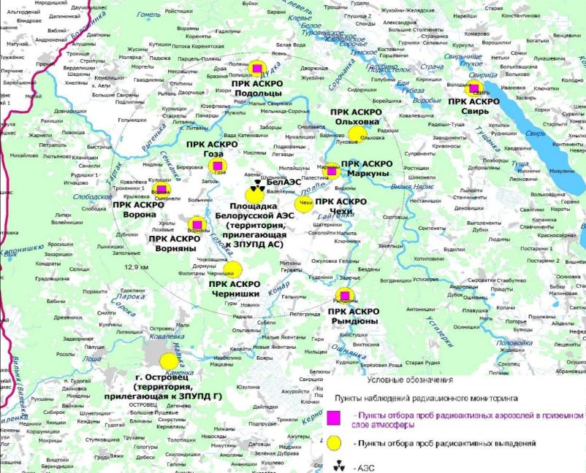
The content of ³H and ¹⁴C in the atmospheric air also did not exceed the previously observable levels (<0.5 Bq/m³).

Figure 8.32 – The layout of observation points for radiation monitoring of atmospheric air in the OZ of the Belarusian NPP

Radioactive fallout
The total beta activity in atmospheric fallout samples in 2022 corresponded to the average long-term observable values for this region and ranged from 0,033 to 0.619 Bq/m² per day.
Activity concentrations of ¹³⁷Cs in monthly fallout samples in 2022 was below the MDA (<0.020 Bq/m²∙per day), which corresponds to the previously observable background values. Activity concentrations of ⁹⁰Sr in all selected samples of atmospheric fallout did not exceed LLMR (<0.2 Bq per sample).
Surface water
Layout of observation points for radioactive contamination of surface water is showed on the Figure 8.33.
The values of total beta activity in surface water samples in 2022 met the background values observable during expeditionary surveys in 2008-2019 for this region, and were in the range of <0,13-0,26 Bq/dm³.
Activity concentrationsof ¹³⁷Cs and ⁹⁰Sr in surface water samples was below the MDA (˂0.2 Bq/dm³, ˂0.3 Bq/dm³, respectively). ³H activity concentrations did not exceed the previously observable background values and ranged from <2.6 to 3.67 Bq/dm³.
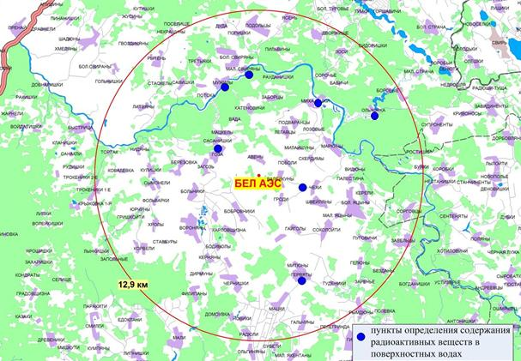
Figure 8.33 – Layout of observation points for radioactive contamination of surface water

Ground water and drinking water
The values of the total alpha-activity in groundwater samples taken in 2022 from wells and boreholes ranged from ˂0.02 to 0.08 Bq/dm³. The values of total beta activity in groundwater samples from wells ranged from ˂0.14 to 1.78 Bq/dm³, from boreholes – 0.12 Bq/dm³. Thus, the values of the total alpha-, beta-activity in groundwater samples taken in 2022 both from wells and boreholes did not exceed previously observable levels
Activity concentrations of ¹³⁷Cs and ⁹⁰Sr in the groundwater samples were lower than MDA (less than 0.2 Bq/dm³ and 0.3 Bq/dm³ respectively).
Hydraulic network (bottom sediments, aquatic and coastal-and-aquatic vegetation, fish fauna)
Measurement results of the ¹³⁷Cs and ⁹⁰Sr activity concentrations in bottom sediment samples taken in 2022 show that at all observation points the levels of radioactive contamination by this radionuclides correspond to the previously observable background values and do not exceed 4. 5 Bq/kg and 4.0 Bq/kg respectively.
Measurement results of the radionuclides activity concentrations in the aquatic and coastal-and-aquatic biogeocenoses of the Belarusian NPP OZ in 2022 show that at all observation points the radioactive contamination with technogenic radionuclides almost met the background values observable in 2016-2020. In 2022, in aquatic and coastal aquatic vegetation the maximum values of the specific activity of ¹³⁷Cs was 15.0 Bq/kg, ⁹⁰Sr - 3.0 Bq/kg.
The activity concentrations sof ¹³⁷Cs in the muscle tissue of the wildfish at the control points of the Viliya river for 2017-2022 were at low and only some samples showed values above the MDA. The measured values of the specific activity of ¹³⁷Cs in the fish fauna at the control points of the Viliya river in 2022 for most of the samples taken did not exceed the MDA (<0.22 Bq/kg). The maximum level of ¹³⁷Cs activity in the fish fauna was established in one sample of roach and amounted to 1.5 Bq/kg. The established values of the specific activity of ⁹⁰Sr in all selected samples of the fish fauna did not exceed 2 Bq/kg.
According to the Belarusian hygienic standards, the normative values of activity concentration of ¹³⁷Cs and ⁹⁰Sr in fresh fish and fish products are not established, and in accordance with the Technical Regulations of the Customs Union TR TS 021/2011 "On Food Safety", they should not exceed, respectively, 130 Bq/kg and 100 Bq/kg. Observable radionuclide activity concentration levels in the muscle tissue of wildfish for the period of 2017-2022 were significantly below the acceptable level of the Technical Regulations of the Customs Union TR TS 021/2011.

Soils
Monitoring of the radionuclides activity concentrations in soils and agricultural lands is carried out at permanent observation points (Fig. 8.34). In the OZ of the Belarusian NPP, 9 points of radiation monitoring of soils and 13 points of radiation monitoring of agricultural lands are determined. The results of laboratory tests of soil samples taken in 2022 showed that at soil monitoring points, the specific activity of ¹³⁷Cs varied from ˂1.0 to 4.1 Bq/kg, ⁹⁰Sr did not exceed 0.97 Bq/kg. At the monitoring points of cultivable and meadow lands, the specific activity of ¹³⁷Cs varied from 2.6 to 5.9 Bq/kg, of ⁹⁰Sr – from ˂0.82 to 5.50 Bq/kg. The specific activity of other controlled technogenic radionuclides at all monitoring points was below the MDA.
Gamma- dose rate at the points of soil radiation monitoring, measured at a height of 1 m above the soil surface, did not exceed 0.1 µSv/h.
According to the results of the assessment of the radioecological parameters data for the period of 2022 and their comparison with the previous period (2021), no significant changes were found.

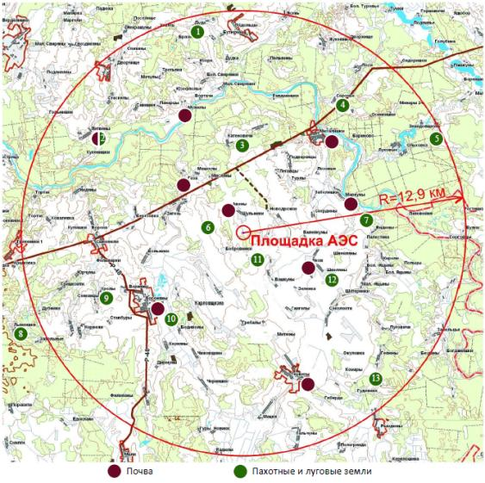
Figure 8.34 - Layout of observation points for radioactive contamination of soils and agricultural lands in the observation zone of the Belarusian NPP

Ground vegetation
In 2022 maximum level of ¹³⁷Cs activity concentration were detected in mushrooms samples and was 286 Bq/kg. Maximum levels of ⁹⁰Sr activity concentration were also observed in mushrooms and was 8 Bq/kg.
Maximum level of ¹³⁷Cs activity concentration in samples of meadow biocenosis was –was detected in grass (mixed sample) and formed 4.6 Bq/kg. Activity concentration of ⁹⁰Sr was in the interval of 2-3 Bq/kg.
The comparative analysis of data for the entire observation period shows that at all observation points at the sites of the forest and boggy meadow phytocenoses within the Belarusian NPP observation area the levels of radioactive contamination with ¹³⁷Cs and ⁹⁰Sr in 2022 met the previously observed background values.
Agricultural products
Values ​​of specific activity of radionuclides ¹³⁴Cs, ¹³⁷Cs, ¹³¹I and ⁹⁰Sr in milk samples, ¹³⁴Cs, ¹³⁷Cs and ⁹⁰Sr in beef samples, radionuclides ⁹⁰Sr, ⁵¹Cr, ⁵⁴Mn, ⁵⁸Co, ⁵⁹Fe, ⁶⁰Co, ⁹⁵Nb, ⁹⁵Zr, ¹³⁴Cs, ¹³⁷Cs in feed samples, foodstuffs and food raw materials at livestock observation points in 2022, in most cases did not exceed the MDA values.
The specific activity of ¹³⁴Cs, ¹³⁷Cs and ¹³¹I in milk samples taken at 7 livestock breeding points did not exceed MDA levels (<0.7; <0.8 and <0.6 Bq/kg, respectively). The specific activity of ⁹⁰Sr in milk varied from <0.05 Bq/kg (Сommercial dairy complex Goza, Сommercial dairy farm Berezovka, Сommercial dairy farm Supronenty) to 0.85 Bq/kg (Сommercial dairy farm Vorona).
Samples of meat (beef) were taken at 2 livestock farming facilities (complex for growing and fattening of beeflings Gervyaty, a farm for growing and beeflings Chekhi). The measured specific activity of ¹³⁴Cs, ¹³⁷Cs in beef did not exceed MDA levels (<0.8; <0.9 Bq/kg, respectively). The specific activity of ⁹⁰Sr in beef varied from 0.09±0.03 Bq/kg (farm for growing and fattening of beeflings Czech Republic) to <0.10 Bq/kg (complex for growing and fattening of beeflings Gervyaty).
In total, 54 samples of coarse, succulent and green fodder were taken at the control livestock-breeding points during the specified period. The specific activity values ​​of ⁵¹Cr, ⁵⁴Mn, ⁵⁸Co, ⁵⁹Fe, ⁶⁰Co, ⁶⁵Zn, ⁹⁴Nb, ⁹⁵Nb, ⁹⁵Zr, ¹³⁴Cs, ¹³⁷Cs, ²²⁶Ra, ²³²Th in feed samples did not exceed MDA levels.
The specific activity of ⁹⁰Sr in feed samples in the context of all 9 control livestock breeding points ranged from 0.17 Bq/kg (Сommercial dairy complex Markuny) in the green mass of cereals and legumes to 1.84 Bq/kg (Collective Farming Unitary Enterprise "Mikhalishki") in rapeseed.
The specific activity of ⁴⁰K radionuclides in feed samples in the context of all 9 control livestock breeding points ranged from 96.8 Bq/kg in wheat (KUP "Vornany") to 310.2 Bq/kg in the green mass of cereals and legumes, feed mixture (MTK Markuny ).
The comparative analysis results of the values ​​of controlled parameters on the network of control points for the entire observation period from 2014 to 2022 testify to the absence of changes in the content of technogenic radionuclides in agricultural products produced in the OZ of the Belarusian NPP.
Annual ambient dose equivalent on the ground (equivalent dose representing the radiation situation)
Data analysis shows that in 2022 the quarterly values ​​of the ambient radiation dose equivalent (hereinafter – ADE) at all observation points (villages of Vornany, Svir, Vorona, Podoltsy, Rymdyuny, Goza, Chekhi, Markuny, Chernishki, Olkhovka) varied in the range of 0.13- 0.22 mSv. The annual ADE values in 2022 fluctuated within 0,64-0,76 mSv, which corresponds to the values of the background radiation levels for this region of the Republic of Belarus.
Thus, the results of radiation monitoring in the vicinity of the Belarusian NPP site for 2022 indicate that the radiation situation in the area of the Belarusian NPP remains stable, the technogenic radionuclides contamination of the environment, agroecosystems and agricultural products meet the levels of "zero" radiation background, registered at the stage of construction and commissioning of power unit No. 1 of the Belarusian NPP.

CHAPTER 9
Radiation-and-environmental monitoring at observation points of the National Environmental Monitoring System of the Republic of Belarus, located outside of the observation zone of the Belarusian NPP

9.1. Radiation monitoring
The results of radiation monitoring at the observation points of the National Environmental Monitoring System (hereinafter – NEMS) in the Republic of Belarus in the area outside the OZ of the Belarusian NPP, show that the radionuclide’s content in the environment corresponds to the global fallout levels caused by nuclear weapons testings in the middle of the last century and technogenic radiation accidents, taking into account the radionuclides decay.
In the area of the Belarusian NPP location there are 10 observation points for atmospheric air radiation monitoring NEMS (Figure 9.1): 3 observation points for atmospheric air radiation monitoring: Lyntupy, Naroch and Oshmyany
3 observation points for radiation monitoring of surface waters: r. Vilia
(v. Bystrica), l. Naroch (v. Naroch) and l. Svir (v. Svir).
4 observation points of Radiation Monitoring Observatories - Landscape and Geochemical Polygons (hereinafter referred to as LGCP): LGCP Bystrica, LGCP Svir, LGCP Gudogay and LGCP Kemelishki.

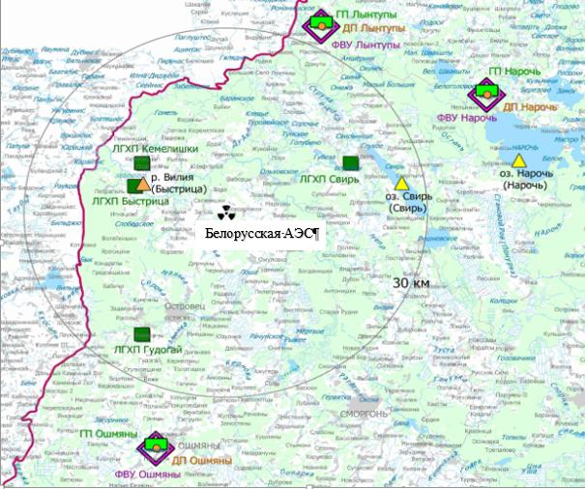
Legend:
Figure 9.1 – Map of radiation monitoring observation points located in the impact area of the Belarusian NPP

Radiation monitoring of atmospheric air is carried out at 3 observation points: Lyntupy, Naroch and Oshmiany.
Observation parameters and frequency:
- gamma- dose rate (daily);
- total beta activity (daily), in fallout and aerosols in the ground-level air;
- activity of gamma-emitting radionuclides (monthly) in fallout and aerosols in the ground-level air;
- activity of ⁹⁰Sr (quarterly) in fallout and aerosols in the ground-level air;
Figures 9.2 and 9.3 show the monthly average values of total beta activity in the samples of natural fallout from the atmosphere and aerosols at observation points in the area of the Belarusian NPP for 2022.
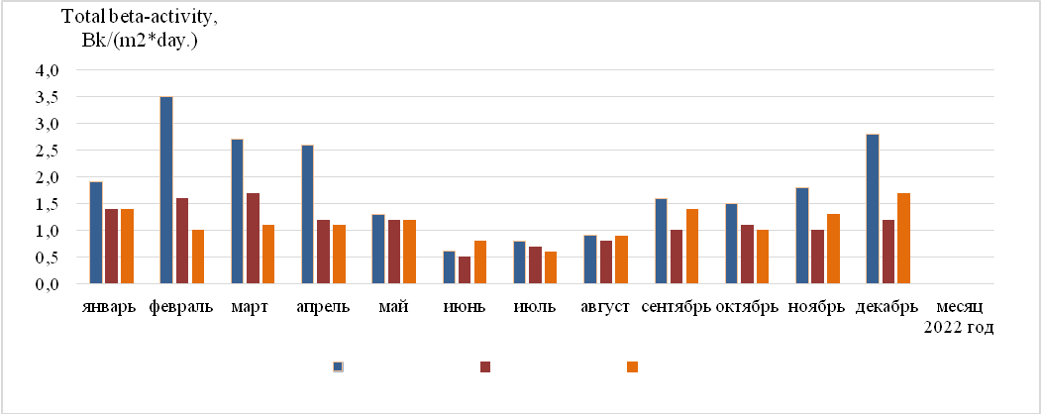
Figure 9.2 - Average monthly values of total beta activity in samples of radioactive atmospheric fallout from the observation points in the area of the Belarusian NPP for 2022

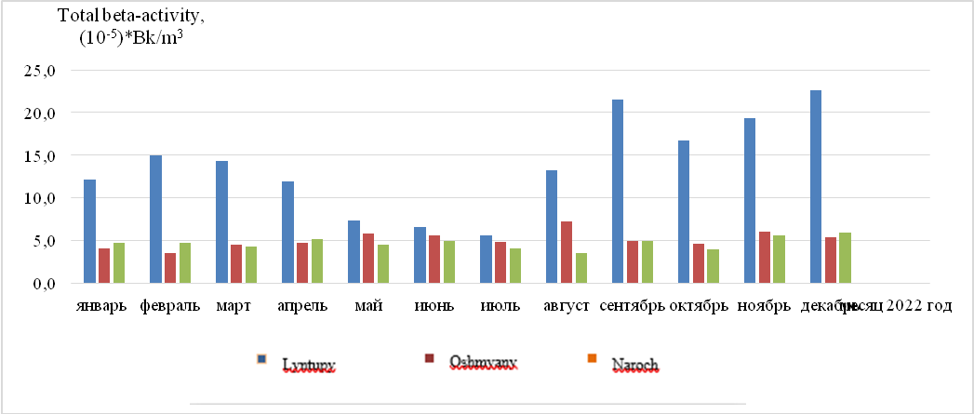
Figure 9.3 - Average monthly values of total beta activity in aerosol samples from the observation points in the area of the Belarusian NPP for 2022

In 2022, the average annual gamma-ray dose at the observation points was 0.10 μSv/h.
The average values of the total beta activity of natural fallout and aerosols in the ground-level air at the observation points met the established long-term values and amounted to 0.5 - 3.5 Bq/m² ×day for atmospheric fallout, (3,5-22,6) ×10⁻⁵ Bq/m³ - for aerosols in the ground-level air.
The activity of gamma-emitting radionuclides (¹³⁷Cs) in the combined monthly samples of radioactive deposition was below the detection limit (<0.01 Bq/m²×day), in monthly aerosol samples - (<0.10-0.17) ×10⁻⁵ Bq/m³, which corresponds to the observed historical values.
The activity of ⁹⁰Sr in aerosol samples did not exceed the LLMR of the applied method which is 0.2 Bq per sample.
The results of atmospheric radiation monitoring at 3 observation points, confirmed by measurements at 10 of the automated radiation monitoring points (hereinafter referred to as ARMP) in the area of the Belarusian NPP location indicate that the launch of the first unit of the Belarusian NPP had not cause negative radiation impact to the environment.
Radiation monitoring of surface water was performed at 3 observation points in the area of the Belarusian NPP: Viliya River (village Bystritsa), Naroch lake (resort area of Naroch) and the Svir lake (Svir village).
Observation parameters:
- total alpha- and beta activity in surface water;
- activity concentration of ¹³⁷Cs, ⁹⁰Sr; activity of ¹³⁷Cs in surface water;
- activity concentration of ¹³⁷Cs, ⁹⁰Sr; activity of ¹³⁷Cs in the bottom sediments.
Frequency of observation: 5 times a year - Viliya (Bystritsa village), 1 time per quarter - Naroch lake (area of resort Naroch) and the Svir lake (Svir village). The bottom sediments are sampled once a year.
Total alpha activity was within <0.01-0.13 Bq/dm³, and the total beta activity is 0.05-0.18 Bq/dm³.
The results of surface water radiation monitoring in 2022 show that the volumetric activity of ¹³⁷Cs was in the range from <0.002 Bq/l (less than MDA) to 0.005 Bq/l, the volumetric activity of ⁹⁰Sr was below 0.009 Bq/l.
Analysis of the radioactive contamination of surface water dynamics in the controlled rivers and lakes showed that the average annual radionuclide concentrations in 2022 were below the reference levels of radionuclides in drinking water established by the Hygienic Standard “Criteria for assessing radiation exposure”, approved by the Decree of the Ministry of the Republic of Belarus dated November 2022 г. № 829 (hereinafter - the Hygienic Standard «Criteria for the evaluation of radiation effects») (reference level for drinking water - 10 Bq/l for ¹³⁷Cs and ⁹⁰Sr ).
In the bottom sediments, the activity concentration of ¹³⁷Cs was in the range of 3.1-5 Bq/kg, and the activity of ⁹⁰Sr was <1-8 Bq/kg, which does not exceed the observed historical values .
The network of observation points for radiation monitoring of soils,
located outside the OZ of the Belarusian NPP includes LGCA: LGCA Bystritsa, LGCA Svir, LGCA Gudogai and LGCA Kemelishki.
Observation parameters and frequency:
- gamma- dose rate;
- vertical distribution of activity of ¹³⁷Cs and ⁹⁰Sr in the soil at 1 cm intervals and at a depth of 10 cm (measurement – once in a year).
The results of the activity of ¹³⁷Cs, ⁹⁰Sr and levels of gamma- dose on 4 LGCA located in the area of the Belarusian NPP location are presented in Table 9.1.

Table 9.1 – Results of ¹³⁷Cs, ⁹⁰Sr activity concentrations and gamma dose rate levels (at heights of 1 m and 3-4 cm) on LGCA

Soil layer, cm | 0-1 | 1-2 | 2-3 | 3-4 | 4-5 | 5-6 | 6-7 | 7-8 | 8-9 | 9-10
LGCA Bystritsa, MD = 0,10/0,10 mSv/h, 12.05.2022
¹³⁷Cs, Bq/kg | 8,5 | 11,5 | 12,7 | 10,1 | 10,0 | 8,4 | 6,9 | 5,2 | <1 | <1
⁹⁰Sr, Bq/kg | <1,4 | <2,8 | 2,7 | 3,3 | <1,9 | <1,4 | <0,9 | <0,9 | <2,4 | <2,1
LGCA Kemelishki, MD = 0,10/0,10 mSv/h , 13.05.2022
¹³⁷Cs, Bq/kg | 2,8 | 2,4 | 2,2 | 2,1 | 1,8 | 2,9 | 5,2 | 3,0 | 4,5 | 2,3
⁹⁰Sr, Bq/kg | <1,1 | <1,5 | <1,9 | <1,8 | 6,9 | 2,9 | 4,2 | 2,1 | 6,7 | <1,3
LGCA Svir, MD = 0,10/0,10 mSv/h, 13.05.2022
¹³⁷Cs, Bq/kg | 1,7 | 2,3 | 1,5 | 1,3 | 2,2 | 1,7 | 1,7 | 1,1 | 1,6 | 2,1
⁹⁰Sr, Bq/kg | 3,5 | 4,1 | 2,5 | 3,3 | 3,5 | 2,8 | 2,1 | <1,7 | 1,9 | 8,3
LGCA Gudogai, MD = 0,10/0,10 mSv/h, 14.05.2022
¹³⁷Cs, Bq/kg | 3,8 | 3,6 | 2,8 | 2,2 | 2,6 | 1,9 | 1,3 | 1,4 | 1,3 | <1
⁹⁰Sr, Bq/kg | 2,7 | <0,9 | 3,2 | 3,2 | 3,8 | 3,1 | 2,2 | 2,7 | <1,6 | 2,8
Note – < X, the result of ¹³⁷Cs activity below MDA, MDA =1 Bq/kg;
< X, the resulting ⁹⁰Sr activity is less than the lower limit of the measurement range (NDT) of the applied method (<0.2 Bq per sample).
Analysis of the data, presented in the Table 9.1 shows that the levels of activity concentrations in soil at the observation points, correspond to the levels of radioactive activity concentrations observed before the accident at the Chernobyl NPP.
On the above-mentioned LGCA, the main reserve of ¹³⁷Cs concentration (about 80%) is in the top 5 cm soil layer.
⁹⁰Sr is distributed in LGCA soils within the margin of changes in profile errors. The difference between maximum and minimum ⁹⁰Sr in soil layers is negligible and is comparable to the error of the method for determining the content of this radionuclide. The higher rate of migration and water soluble forms of ⁹⁰Sr have led to a more intensive penetration into the soil.
The results of soil radiation monitoring in 2022 did not reveal new trends related to the processes of vertical migration of radionuclides in the soil compared with the results of measurements of previous years, including 2018.
Conclusions:
The results of the radiation monitoring carried out in 2022 at the NEMS observation points located in the area of the Belarusian NPP locatin show that the introduction of the first unit of the Belarusian NPP had no effect on the radiation situation:
- levels of radionuclide activity concentration in the air corresponded to the values, observed in previous years and were below 0.10 mSv/h;
- the radiation situation in water bodies remained stable. Average content of ¹³⁷Cs and ⁹⁰Sr at observation points were significantly lower than reference levels of radionuclides in drinking water, established by the Hygienic Standard «Criteria for Evaluation of Radiation Exposure» (reference level - 10 Bq/l);
- soil monitoring results show no deviation from multi-year processes or new trends in the presence of radionuclides in soil.
In addition, the Belarusian NPP provides continuous operational monitoring of the radiation situation with the use of Automated Radiation Monitoring System (hereinafter – ARMS).
ARMS of the Belarusian NPP (Figure 9.3) consists of 10 automatic measuring points (AMP). 3 АMP are located in the villages of Gervyaty, Mihaliski, Trokeniki, located in the observation zone (12.9 km) of the Belarusian NPP, the other 7 AMP are located in the OZ in the settlements of Lyntupy, Naroch, Kemelishki, Kotlovka, Ostrovets, Gudagay, Oshmiany.

9.2. Ecological monitoring
The surface waters monitoring is performed in accordance with the order of the Ministry of Natural Resources and Environmental Protection of the Republic of Belarus dated July 19, 2019 No. 180-OD “On surface and ground waters monitoring” (As amended by the Order of the Ministry of Natural Resources and Environmental Protection of the Republic of Belarus dated August 1, 2022 № 235-OD «On amendment of the order of the Ministry of Natural Resources and Environmental Protection of the Republic of Belarus dated July 19, 2019 № 180-OD»).
The surface waters monitoring is performed in the Viliya river at the observation point of the state observations network 0.3 km to the north-east of the settlement of Bystritsa (10.0 km from the border with the Republic of Lithuania) for the following hydrochemical indicators:
water physical properties and gas composition (temperature, suspended solids, hydrogen index (pH), dissolved oxygen, electrical conductivity), BOD₅, COD_{Cr}, nitrogen-containing (ammonium ion, nitrate ion, nitrite ion, the Kjeldal nitrogen) and phosphorus-containing (phosphate ion (including hydro- and dihydroforms), total phosphorus) matters, metal content (total iron, manganese, copper, zinc, nickel, chromium, lead, cadmium), oil and oil products in dissolved and emulsified state, synthetic anionic surfactants (including alkyl oxyethylated sulfates, alkyl sulfonates, olefinsulfonates, alkyl benzosulfonates, alkyl sulfates, sodium and potassium salts of fatty acids) - 12 times a year annually;
mineral composition (magnesium, calcium, hydrocarbonate-ion, chloride-ion, sulfate-ion, water salt content) - 7 times a year;
mercury, arsenic - 1 time a year;
Monitoring results (see table 9.2) of surface waters in 2022, haven’t detected any new trends in the water quality of the Vilia River in comparison with measurements from previous years.
However, the one-time exceedances of water quality standards for iron (January 2022), manganese (June 2022), copper (December 2022), zinc (October 2022) and chromium (June 2022) were due to their natural background content and not associated with the activities of the Belarusian nuclear power plant.

Table 9.2. Analysis of observations in the Viliya river 0.3 km to the north-east of the settlement of Bystritsa in 2022

Parameter of | MPC for the Viliya river | Average | Maximum | Minimum
Suspended solids (mg/dm3) | maximum 25 mg/dm3 | 7,6 | 9,05 | 6,6
Dissolved oxygen (mgO2/dm3) | In the ice-cover period there should be at least 6 mgO2/dm3, open - 8 mgO2/dm3 | 10,7 | 12,3 | 8,3
COD5 (mgO2/dm3) | 3 mgO2/dm3 | 2,4 | 3,1 | 1,2
CODCr (mgO2/dm3) | 25 mgO2/dm3 | 28,5 | 33,2 | 22,4
Ammonium ion (mgN/dm3) | 0.39 mgN/dm3 | 0,097 | 0,224 | 0,014
Nitrite ion (mgN/dm3) | 0.024 mgN/dm3 | 0,014 | 0,031 | 0,0072
Nitrate ion (mgN/dm3) | 9.03 mgN/dm3 | 1,15 | 2,1 | 0,44
Phosphate ion (mgP/dm3) | 0.066 mgP/dm3 | 0,036 | 0,079 | 0,011
Phosphorus total (mg/dm3) | 0.2 mg/dm3 | 0,067 | 0,13 | 0,026
Iron total (mg/dm3) | 0.195 mg/dm3 | 0,325 | 0,504 | 0,204
Manganum (mg/dm3) | 0.030 mg/dm3 | 0,076 | 0,147 | 0,045
Copper (mg/dm3) | 0.0043 mg/dm3 | 0,0024 | 0,0059 | 0,0008
Zinc (mg/dm3) | 0.030 mg/dm3 | 0,013 | 0,075 | 0,0005
Nickel (µg/dm3) | 34 μg/dm3 | <3 | 6 | 0,3
Oil products (mg/dm3) | 0.05 mg/dm3 | 0,016 | 0,025 | 0,0089
Anionic surfactants (mg/dm3) | 0.1 mg/dm3 | <0,025 | <0,025 | <0,025
the Kjeldahl total nitrogen (mg/dm3) | 5 mg/dm3 | 1,645 | 2,04 | 1,14
Hydrogen index (pH) | should be within 6.5-8.5 | 8,2 | 8,4 | 8,1
Hexachlorobenzene (ug/dm3) | 0,05 | <0,004 | <0,004 | <0,004
Cadmium (mg/dm3) | 0.005 mg/dm3 | <0,0005 | <0,0005 | <0,0001
Calcium (mg/dm3) | 180 mg/dm3 | 52,9 | 60 | 44
Magnesium (mg/dm3) | 40 mg/dm3 | 22,7 | 27 | 20
Mineralization of water (mg/dm3) | maximum 1000 mg/dm3 | 261,3 | 308 | 228
Arsenicum (mg/dm3) | 0.05 mg/dm3 | <0,001 | <0,001 | <0,001
Mercury (mg/dm3) | 0,07 мкг/дм³ | <0,02 | <0,02 | <0,02
Plumbum (µg/dm3) | 14 μg/dm3 | <5 | 2,7 | <0,01
Sulfate ion (mg/dm3) | 100 mg/dm3 | 24,2 | 27,5 | 23,1
Temperature (°C) |  | 9,8 | 22,7 | 0,1
Electrical conductivity (µS/cm) | – | 374,3 | 403 | 344
Chloride ion (mg/dm3) | 300 mg/dm3 | 15,7 | 17,7 | 13,5
Chromium (mg/dm3) | 0.005 mg/dm3 | <0,001 | 0,013 | 0,0004

CHAPTER 10
Awareness raising on radiation-and-environmental monitoring

Since 2009 the Nuclear Power Plant Information Center in the city of Ostrovets has been operating as part of the Belarusian NPP. The center is designed to inform the population on the nuclear power issues and on the progress of the Belarusian NPP construction.
Specialists of the Information and Public Relations Department of the Information Center and other employees of the Belarusian NPP share information on the development of the global nuclear industry, about the implemented project, about modern and reliable technologies used during the Belarusian NPP construction. There you can find in a free access the EIA (environmental impact assessment) materials of the Belarusian NPP.
The Information Center offers it services (activities for visitors, excursions to the construction site of the Belarusian NPP exclusively free of charge.
In November 2020 the Information Center created an exposition in the Demonstration building of the Belarusian NPP training center.
In 2022 the NPP information Center was visited by more than 3,500 people in 169 delegations. Compared to 2021, the number of visitors increased by 35.72%.
For visitors of the information center there were held lectures, excursions, seminars concerning the construction of the Belarusian NPP, features of the project «NPP-2006», safety systems used at modern nuclear power plants, impact of the NPP on the ecology of the region and other topics.
Representatives of domestic and foreign mass media (hereinafter - the media) were given practical assistance in the preparation of TV stories, reports and interviews on the progress of the Belarusian NPP construction.
A press tour for bloggers of the Republic of Lithuania was held. Together with JSC «Second National TV Channel» (ONT) a documentary film «The Station» has been prepared.
A report on the avtivities of the Belarusian NPP was prepared for the regional public-political newspaper «Astravetskaya Prauda». The video studio of the regional newspaper was assisted in the release of the television program «Hands of the Atom», which told about the best workers of the Belarusian NPP.
Assistance was provided in the preparation of materials about the Belarusian NPP to the newspaper «Gomel Pravda», the magazine «Energy Efficiency», VGTRK -«Russia», the region newspaper «Lidskaya Pravda», BELTA, Belarusian Radio, Belteleradiocompany, etc.
The cooperation with the newspaper «Energetics of Belarus» in the field of materials preparation about employees of the Belarusian NPP in the rubric «NPP in persons» has been continued.
In total for 2022, 14 press events were organized with the participation of domestic and foreign media.
Information support was provided in the preparation of materials about the activities of the Belarusian NPP for the sectoral media: «Energy Strategy», «Energy of Belarus».
The Belarusian NPP took part at the XXVI Belarusian Energy and Environmental Forum Energy Expo 2022.
For the purpose of prompt and comprehensive lighting of the Belarusian NPP, more active and meaningful informing about nuclear power to the youth audience is kept official pages of the enterprise in popular social networks Facebook, Vkontakte, Odnoklassniki, Instagram. The video content of the Belarusian NPP’s YouTube account continues to grow.
The content of the website of the Belarusian NPP is regularly updated. Since 2022, the website of the enterprise in the section «Radiation situation» reflects online the current information about the radiation background in the Belarusian NPP radiation control area at a 30-minute update rate.

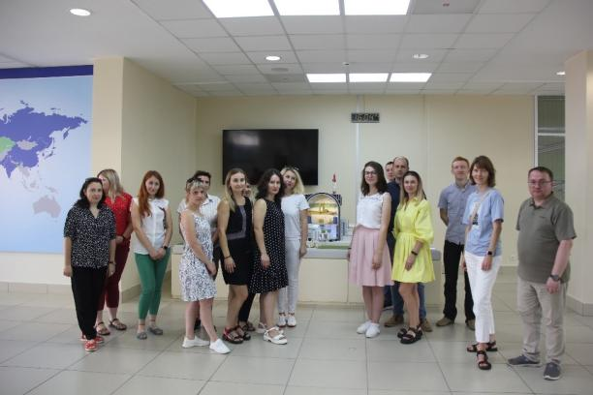
Figure 10.1 – NPP Information Center

Since 2015 the Information Center for Atomic Energy (hereinafter referred to as ICAE) has been operating in Minsk. It is equipped with a modern multimedia movie theater, educational models “Universal radiometer”, “Key safety systems of the nuclear power plant”, “The principle of the nuclear power plant operation on the example of household appliances”, an interactive model of the Belarusian NPP (made using the augmented reality method), as well as a touch screen panel with special programs (Fig. 10.2)


Figure 10.2 - Information Center for Atomic Energy

ICAE organizes educational and vocational activities, exhibitions of creative works, scientific and technical conferences, etc. (fig. 10.3).
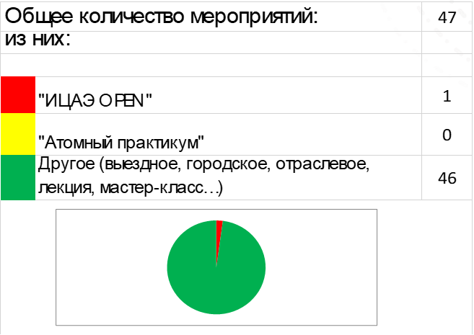
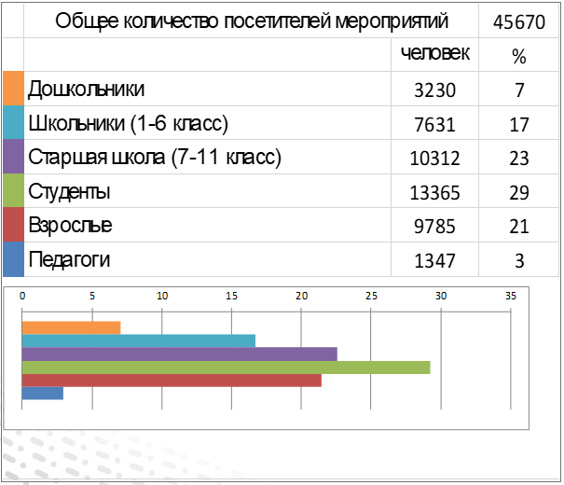
Figure 10.3 - Work of the ICAE in 2022

Information about the Belarusian NPP construction, the latest news about nuclear power is posted in Belarusian, Russian and English on the official website of the enterprise http://belaes.by, as well as in popular social networks: Facebook, VKontakte, Odnoklassniki. Radiation data in the area of the Belarusian NPP is updated daily on the official website, it is received from 10 points of the automatic radiation monitoring system - ARMS, located around the Belarusian NPP.
The issues of the nuclear power development in the Republic of Belarus, the progress of the Belarusian NPP construction, training of specialists for the industry are covered on the pages and websites of the leading national media. Information materials and videos prepared together with the employees of the enterprise are placed on the pages of newspapers and magazines, in information and information-analytical television programs on TV channels Belarus-1, Belarus-3, ONT, STV.
Since 2018 a joint monthly information project of the Ministry of Energy of the Republic of Belarus, the Belarusian NPP and the newspaper “Respublika” “Energy of the Future” has been implemented, and it reflects the most important issues of the nuclear power plant construction in the Republic of Belarus.

